Table of Contents

Steps followed in Algorithm 2

Various use Cases. 3

Varying number of epochs. 3

1.) Epochs = 10 3

2.) Epochs = 100 4

3.) Epochs = 1000 5

4.) Epochs = 2000 6

5.) Epochs = 3000 7

Overall Performance by varying epochs 8

Varying filter size 9

1.) Filter size is 2x2 for both layers. 9

2.) Filter size is 5x5 for both layers. 10

3.) Filter size 10x10 for both layers. 11

4.) Filter size 20x20 for both layers 12

Overall Performance 13

Varying number of filters 14

1.) First layer of size 4 and second layer of size 16 14

2.) First layer is 6 and second layer is 16 15

3.) First layer is 8 and second layer is 16 16

4.) First layer is 6 and second layer is 10 17

5.) First layer is 6 and second layer is 18 18

6.) First layer is 8 and second layer is 20 19

Overall Performance 20

Varying size of fully connected Layers 21

1.) Both fully connected layers of size 50 21

3.) Fully connected layer 1 = 100 and fully connected layer 2 = 50 23

4.) Fully connected layer 1 = 150 and fully connected layer 2 = 150 24

5.) Fully connected layer 1 = 120 and fully connected layer 2 = 84 25

6.) Fully connected layer 1 = 200 and fully connected layer 2 = 200 26

Overall Performance 27

Varying the regularizer 28

1.) Weight decay = 1e-8 28

2.) Weight decay = 1e-10 29

3.) Weight decay = 1e-15 30

4.) Weight decay = 0.00001 31

My Comments 32

Source Code 32

References Used 39

# Steps followed in Algorithm

# Various use Cases.

Here I have listed accuracy result with various combinations.

# Varying number of epochs.

Here are the results when I varied epoch steps.

Constant Variables:

Layers as described in HW itself. I have just varied number of epochs keeping all configuration same as mentioned in the HW itself. Learning rate = 0.001

## 1.) Epochs = 10

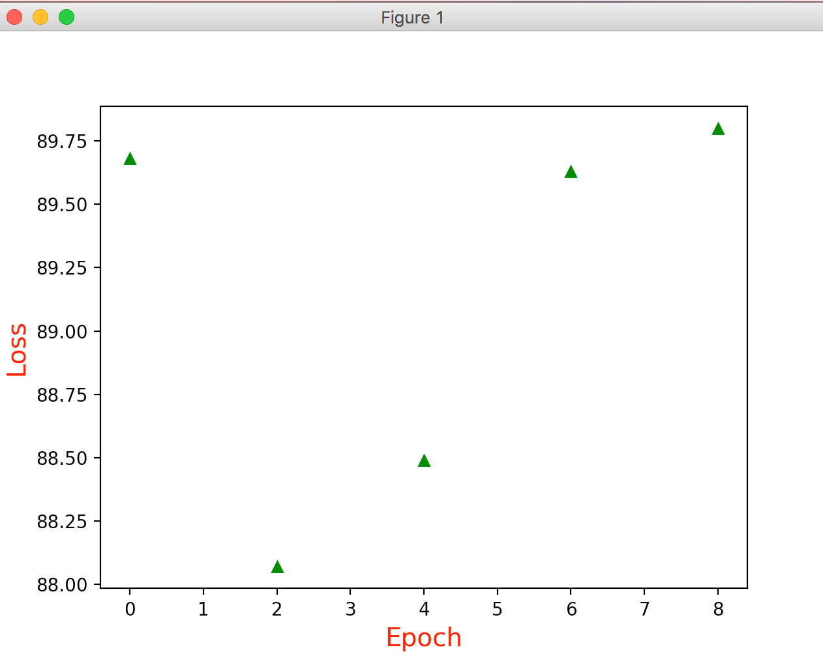

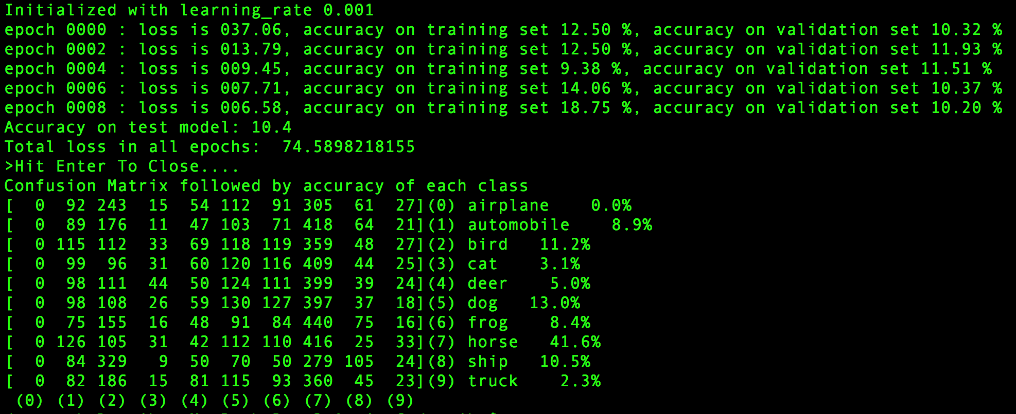

## 2.) Epochs = 100

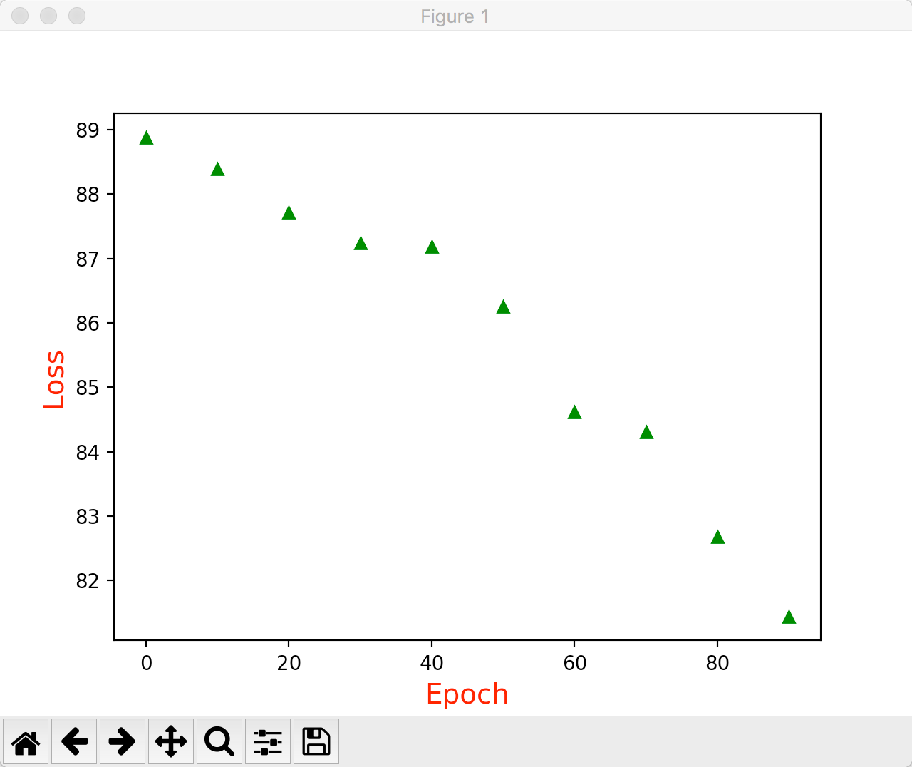

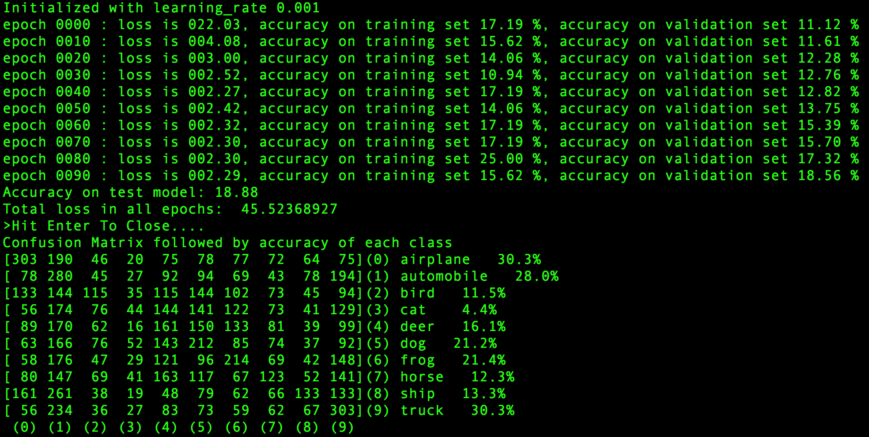

## 3.) Epochs = 1000

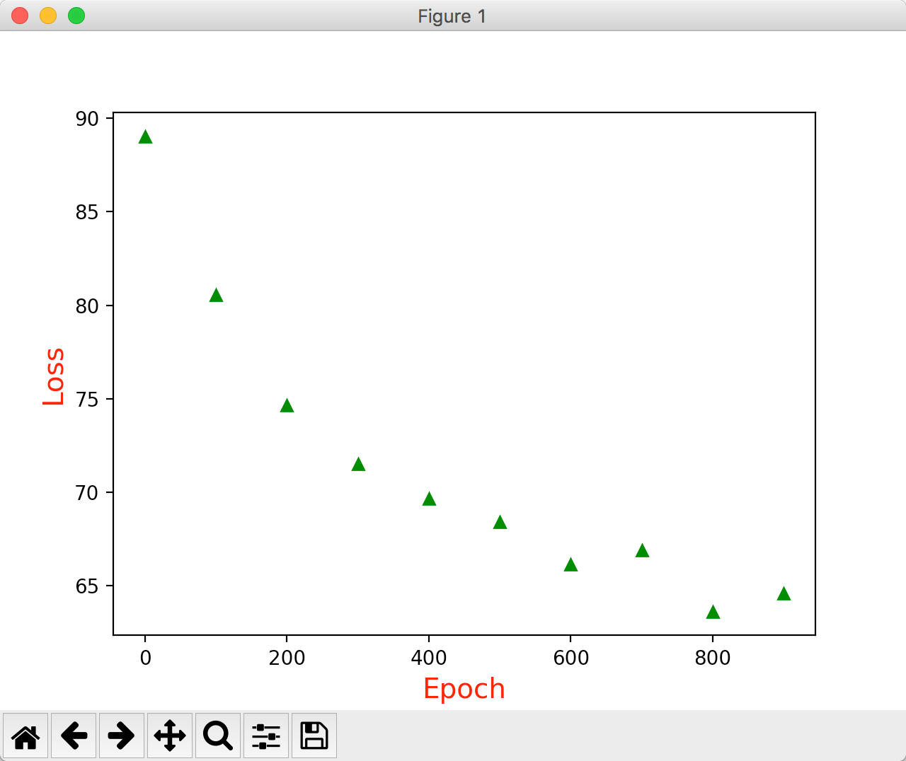

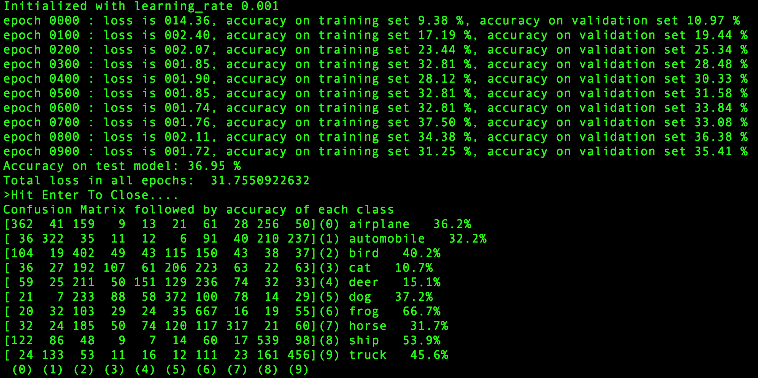

## 4.) Epochs = 2000

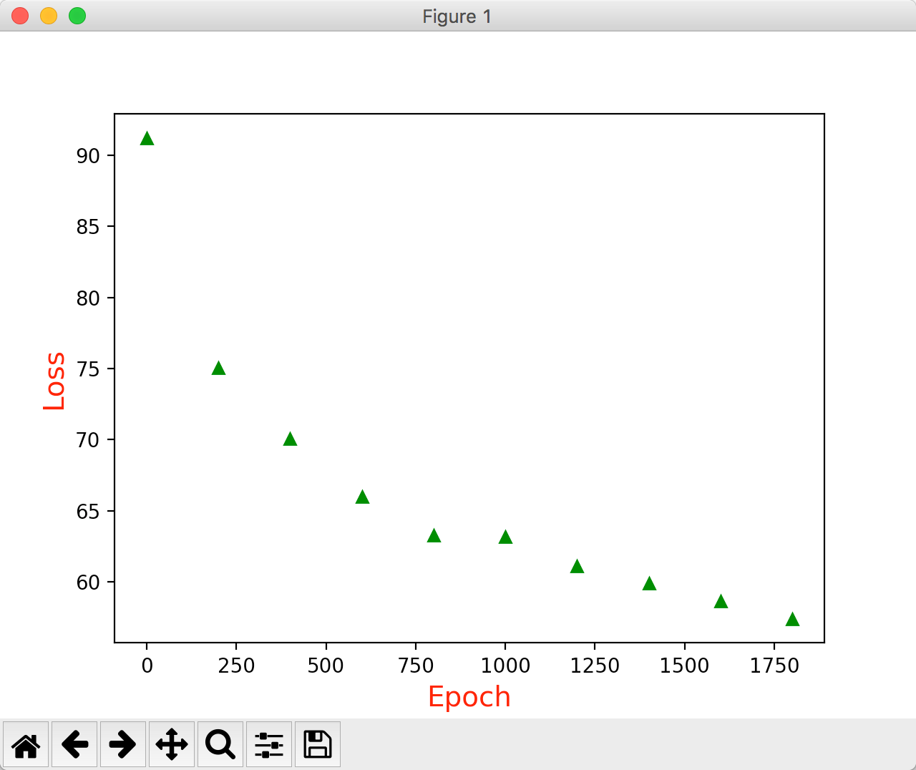

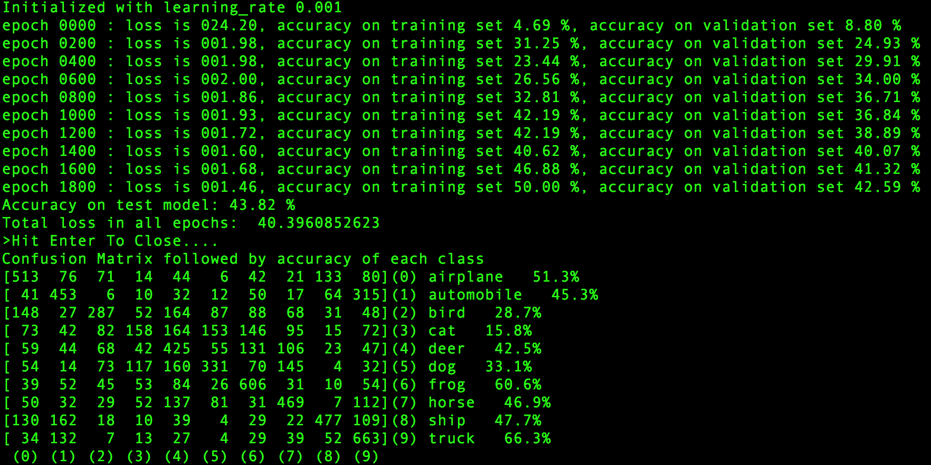

## 

## 5.) Epochs = 3000

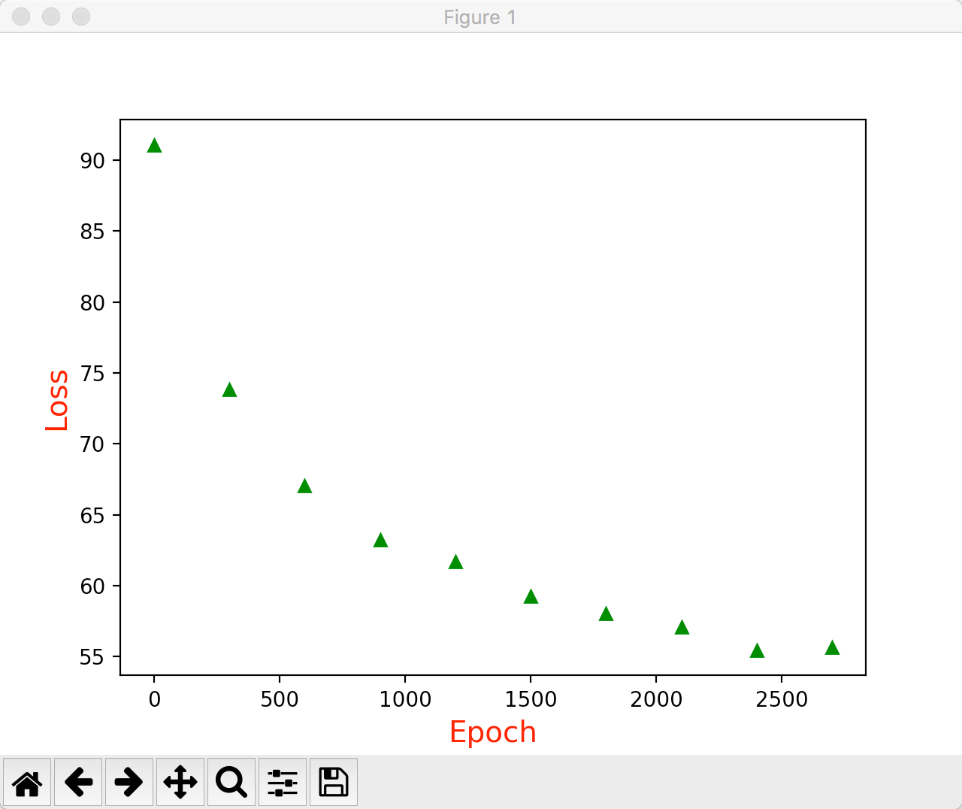

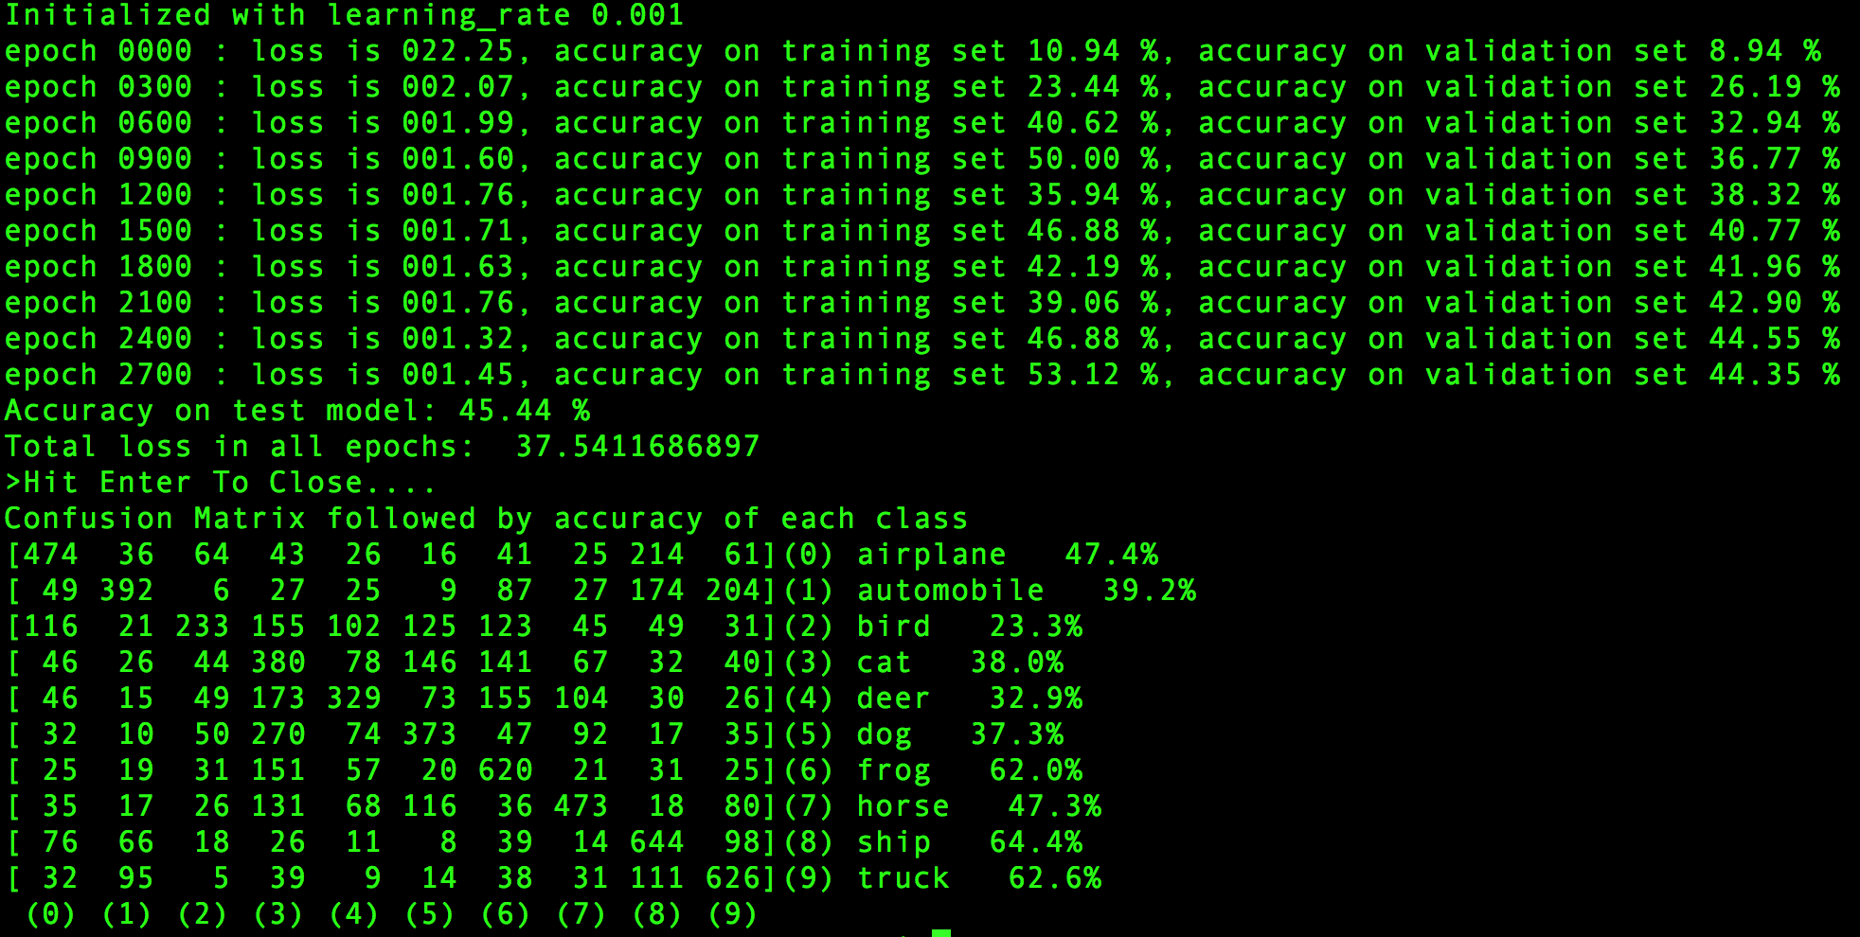

## Overall Performance by varying epochs

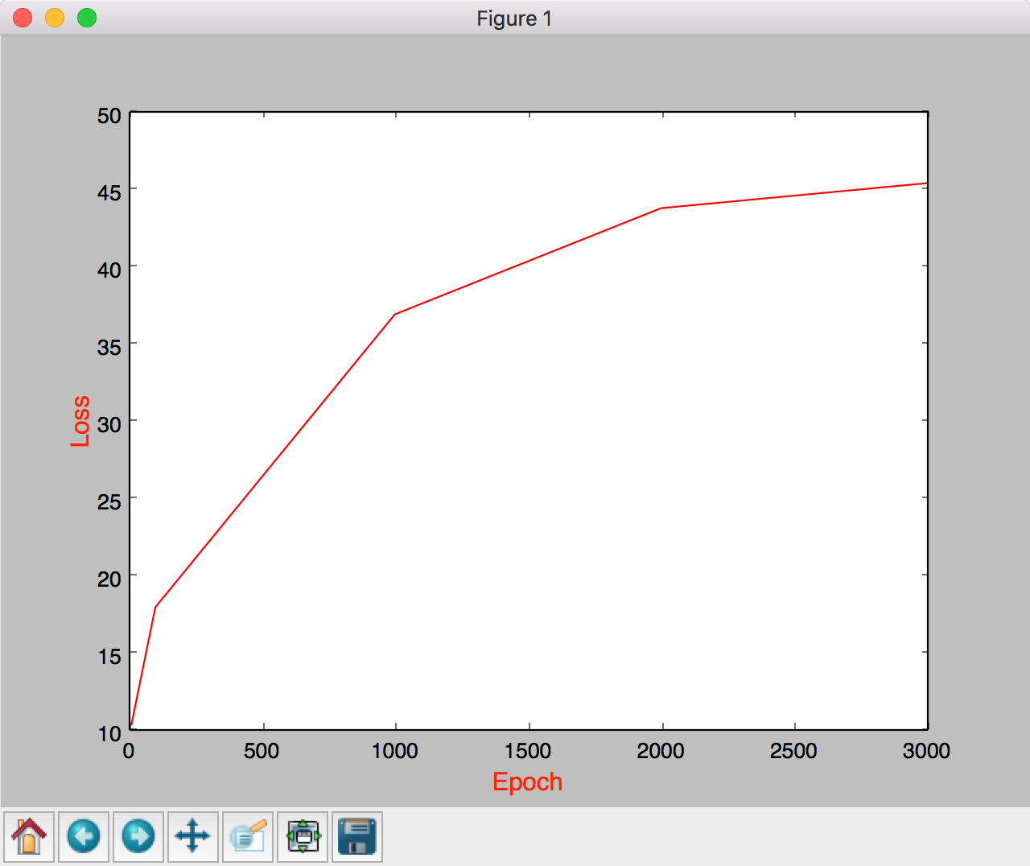

# Varying filter size

Constants: Learning rate = 0.001.

Number of epochs = 1000

## 1.) Filter size is 2x2 for both layers.

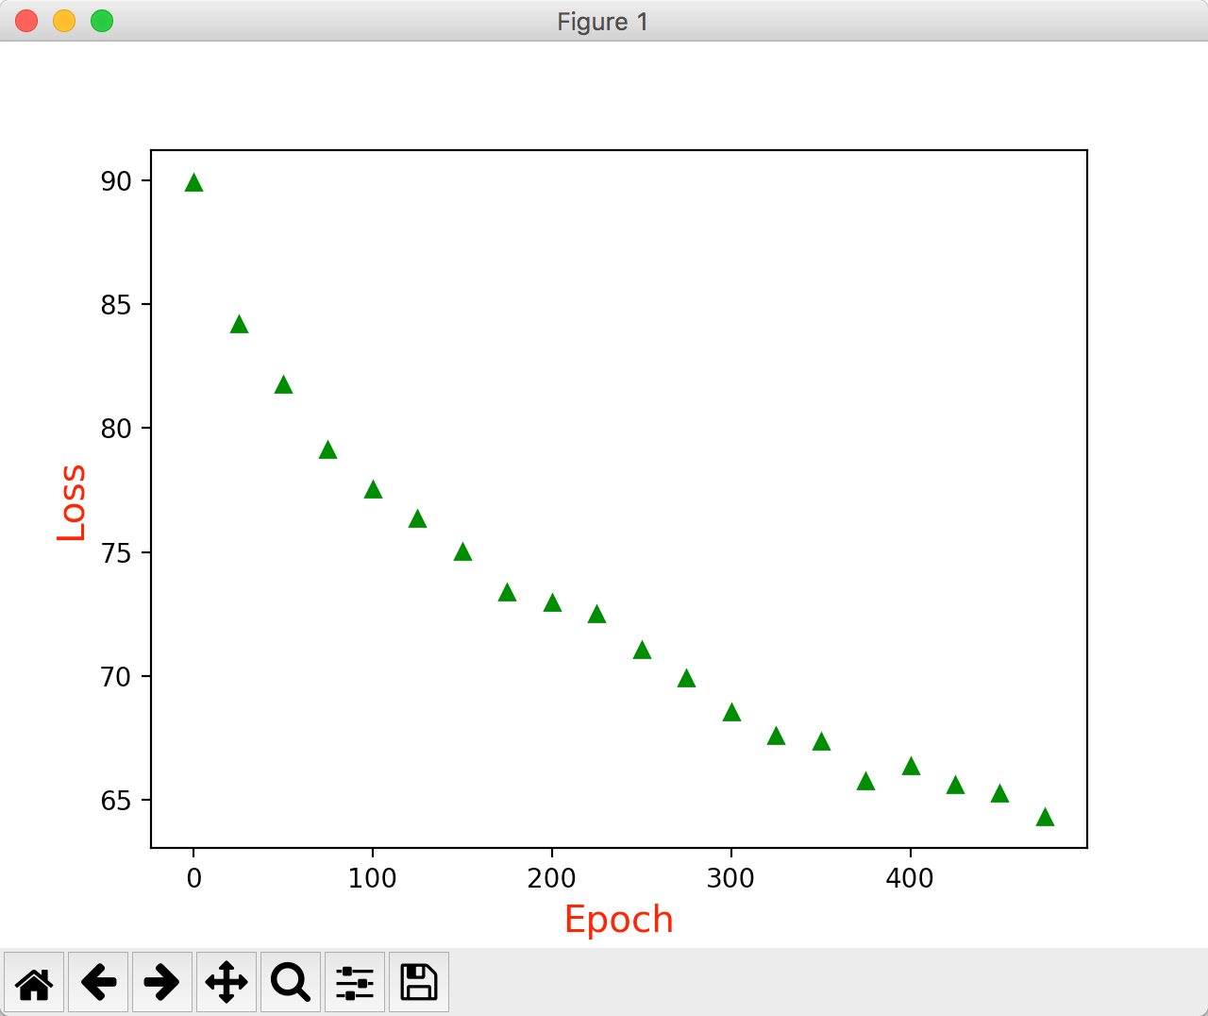

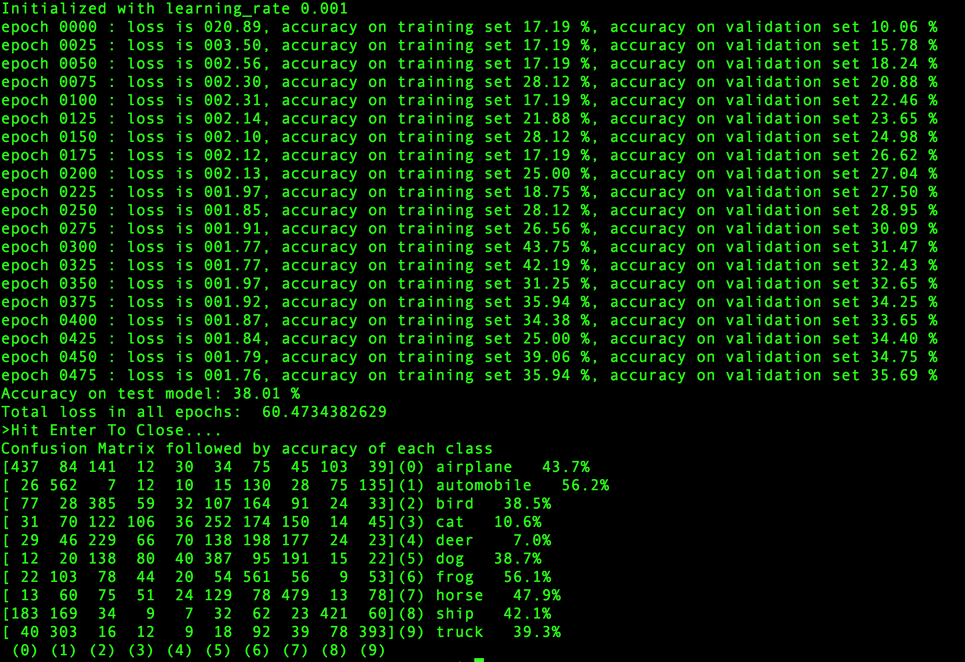

## Filter size is 5x5 for both layers.





## Filter size 10x10 for both layers.

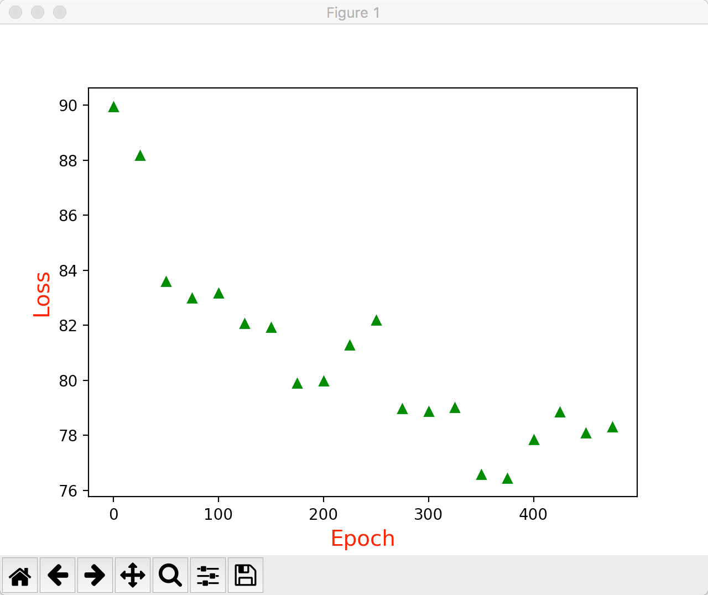

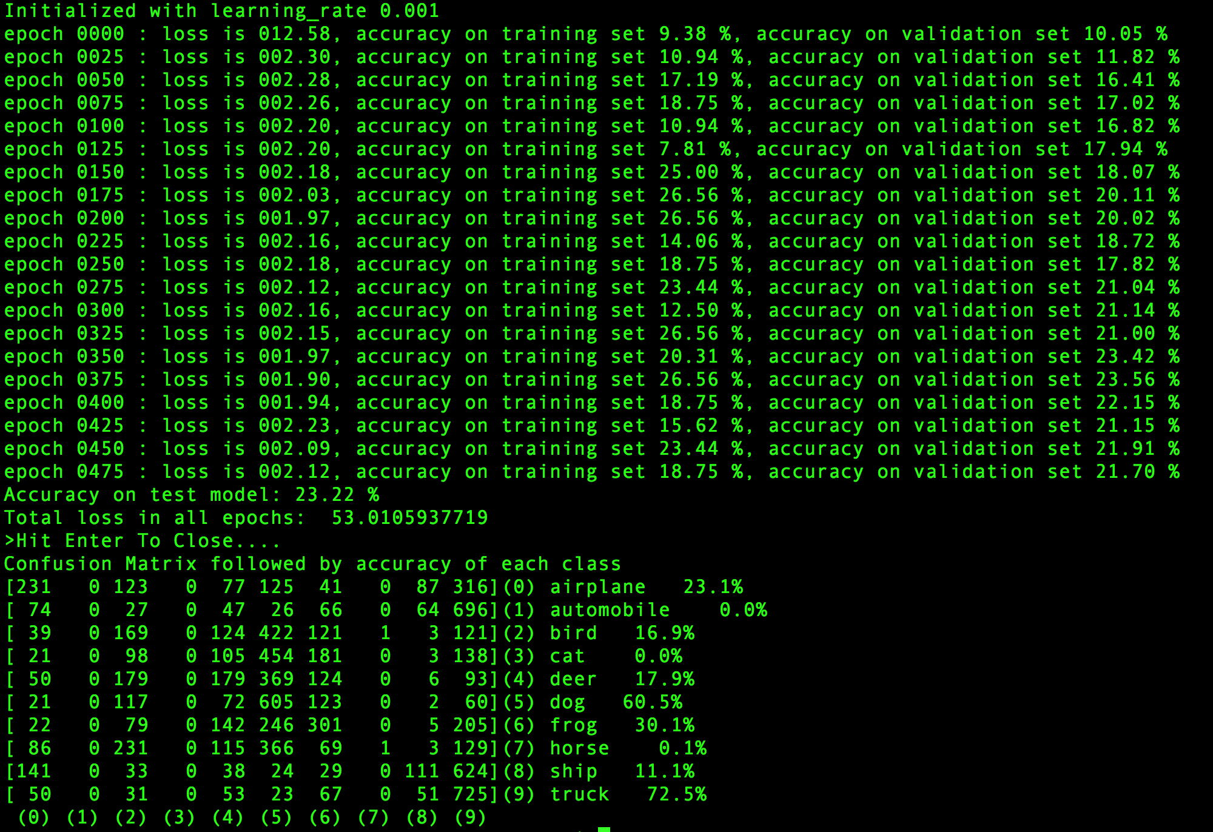

## Filter size 20x20 for both layers

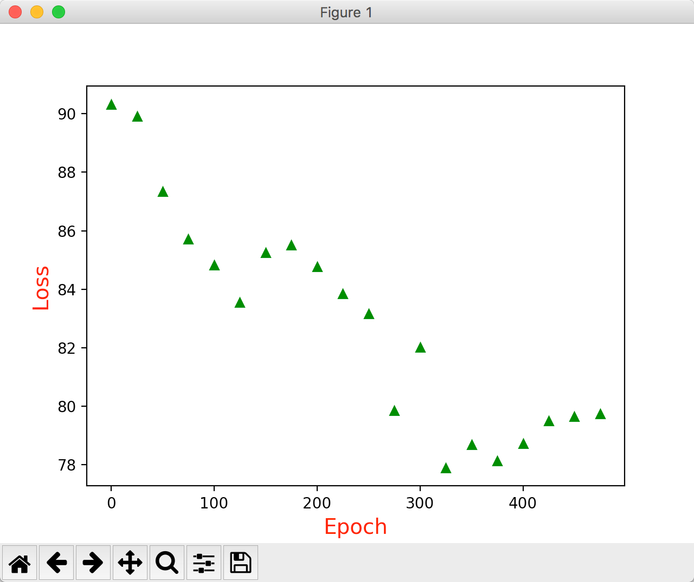

# deepika:private:var:folders:vs:41q3b56n323dlcj_3jz6f8j00000gn:T:DMD311A89FB-1684-45EC-8CEB-E24BEF94B18E:Assign6_—_ubuntu_ip-172-31-54-231____tensorflow-cifar-10_—_-bash_—_143×44.png

## Overall Performancedeepika:private:var:folders:vs:41q3b56n323dlcj_3jz6f8j00000gn:T:DMD9CECFC44-8466-414A-899B-57EC62D1940C:Figure_1.png

# Varying number of filters

Constant: learning rate 0.001, epochs 500, Filter Size 5x5. Epoch = 1000

## First layer of size 4 and second layer of size 16

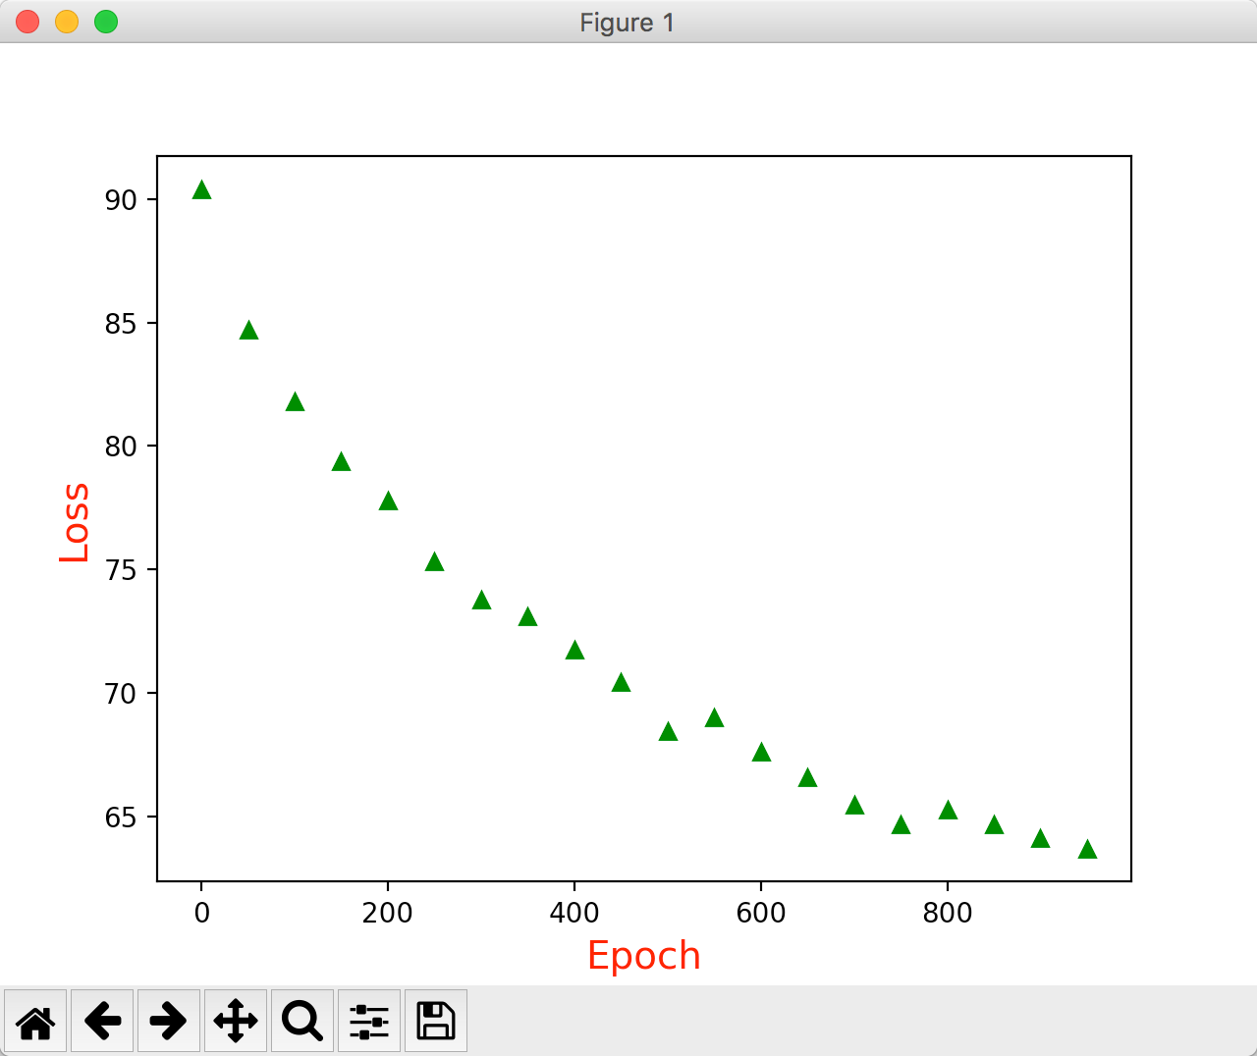

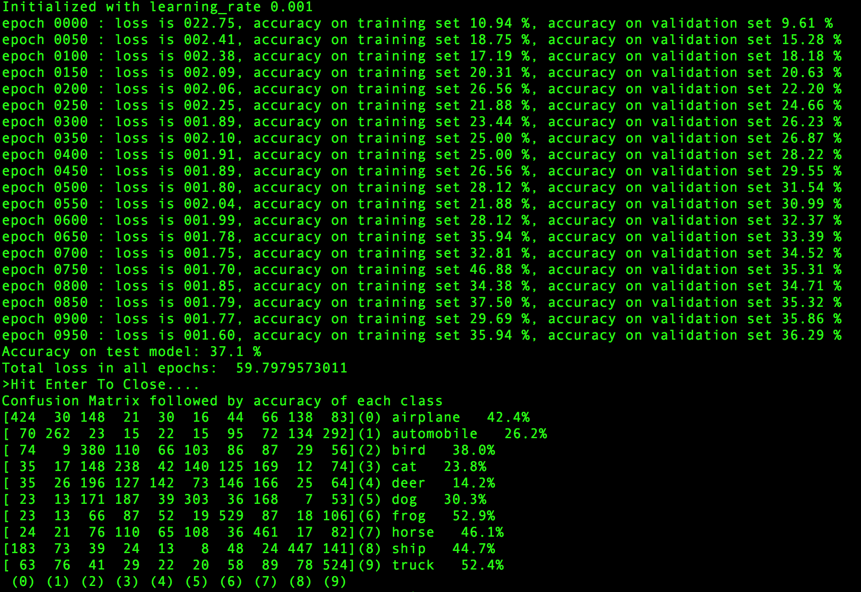

## First layer is 6 and second layer is 16

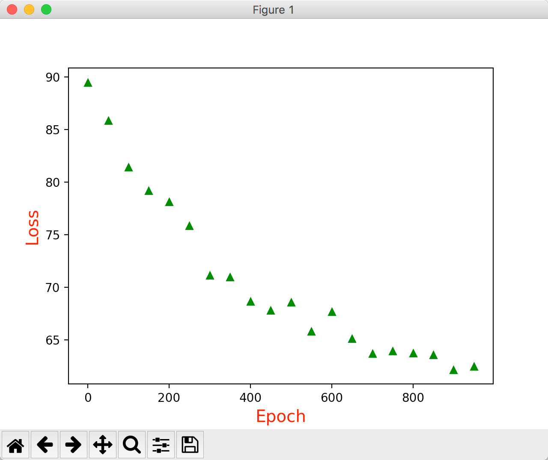

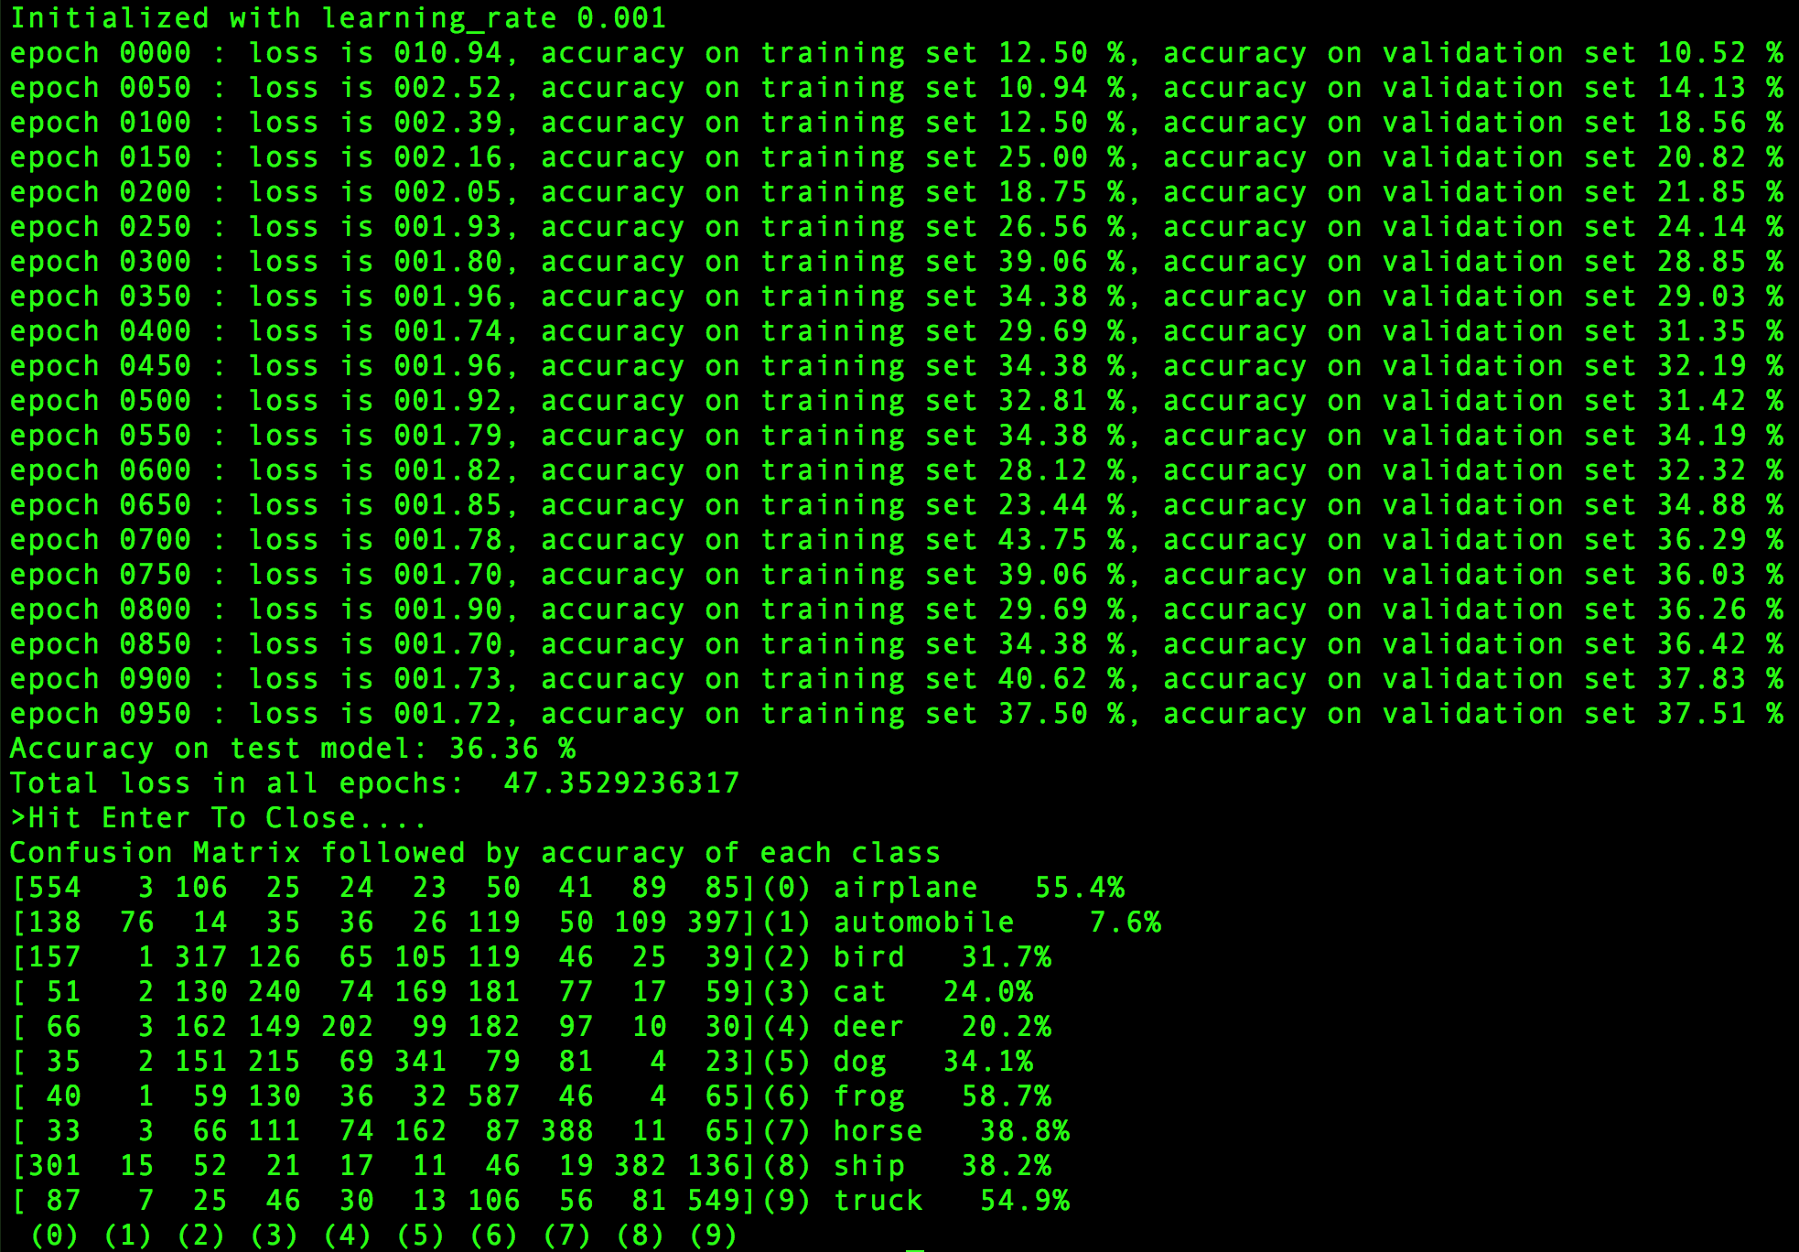

## First layer is 8 and second layer is 16

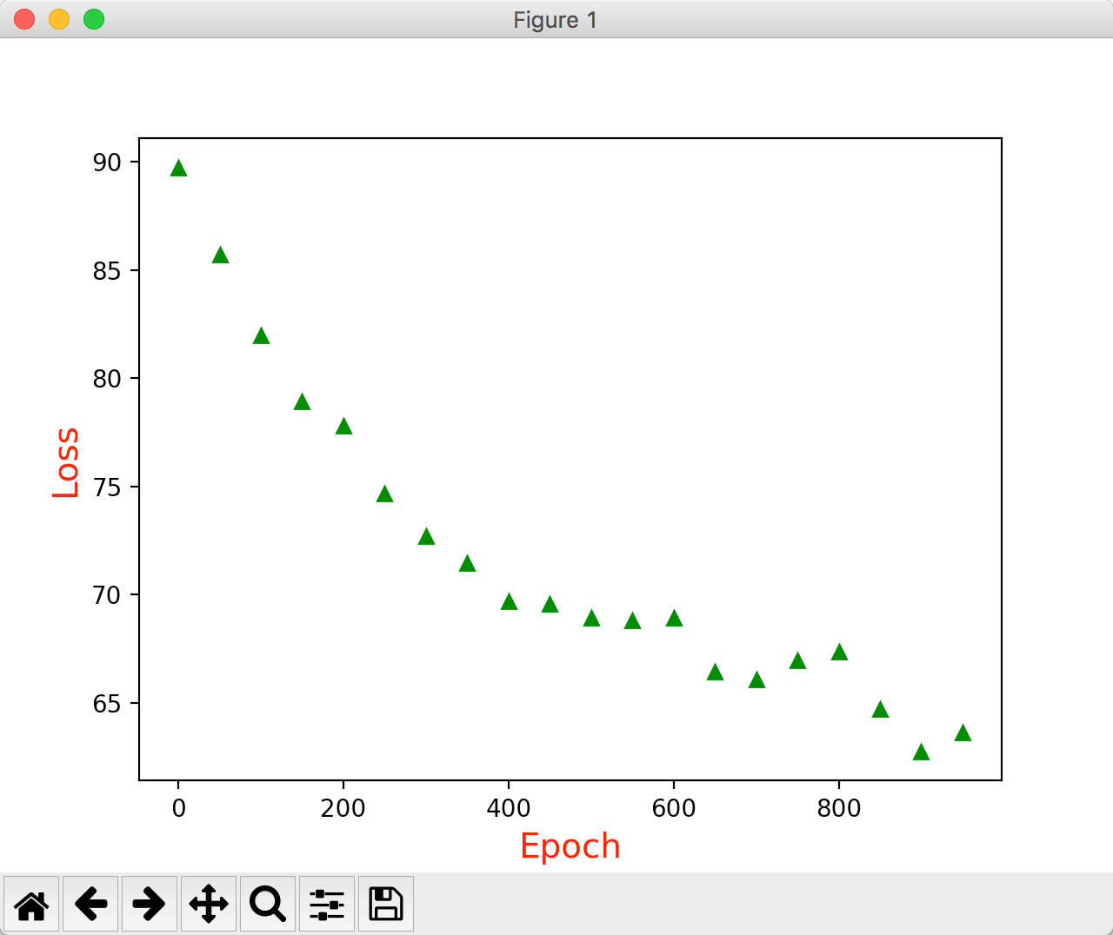

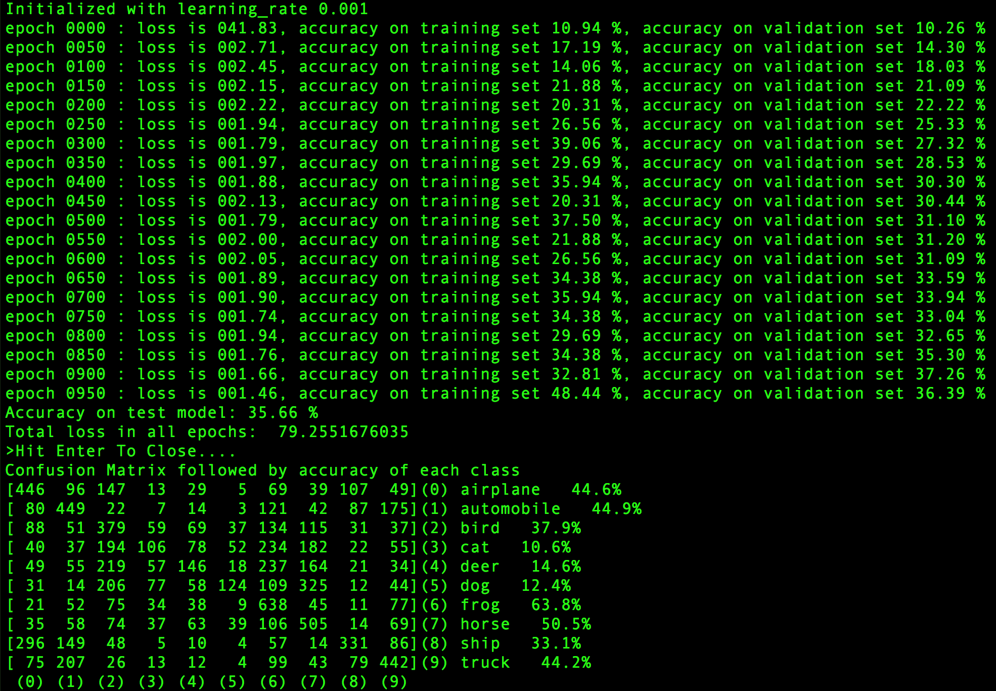

## First layer is 6 and second layer is 10

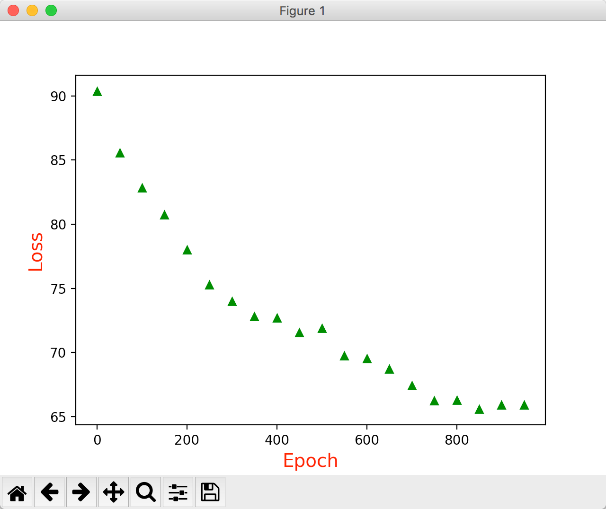

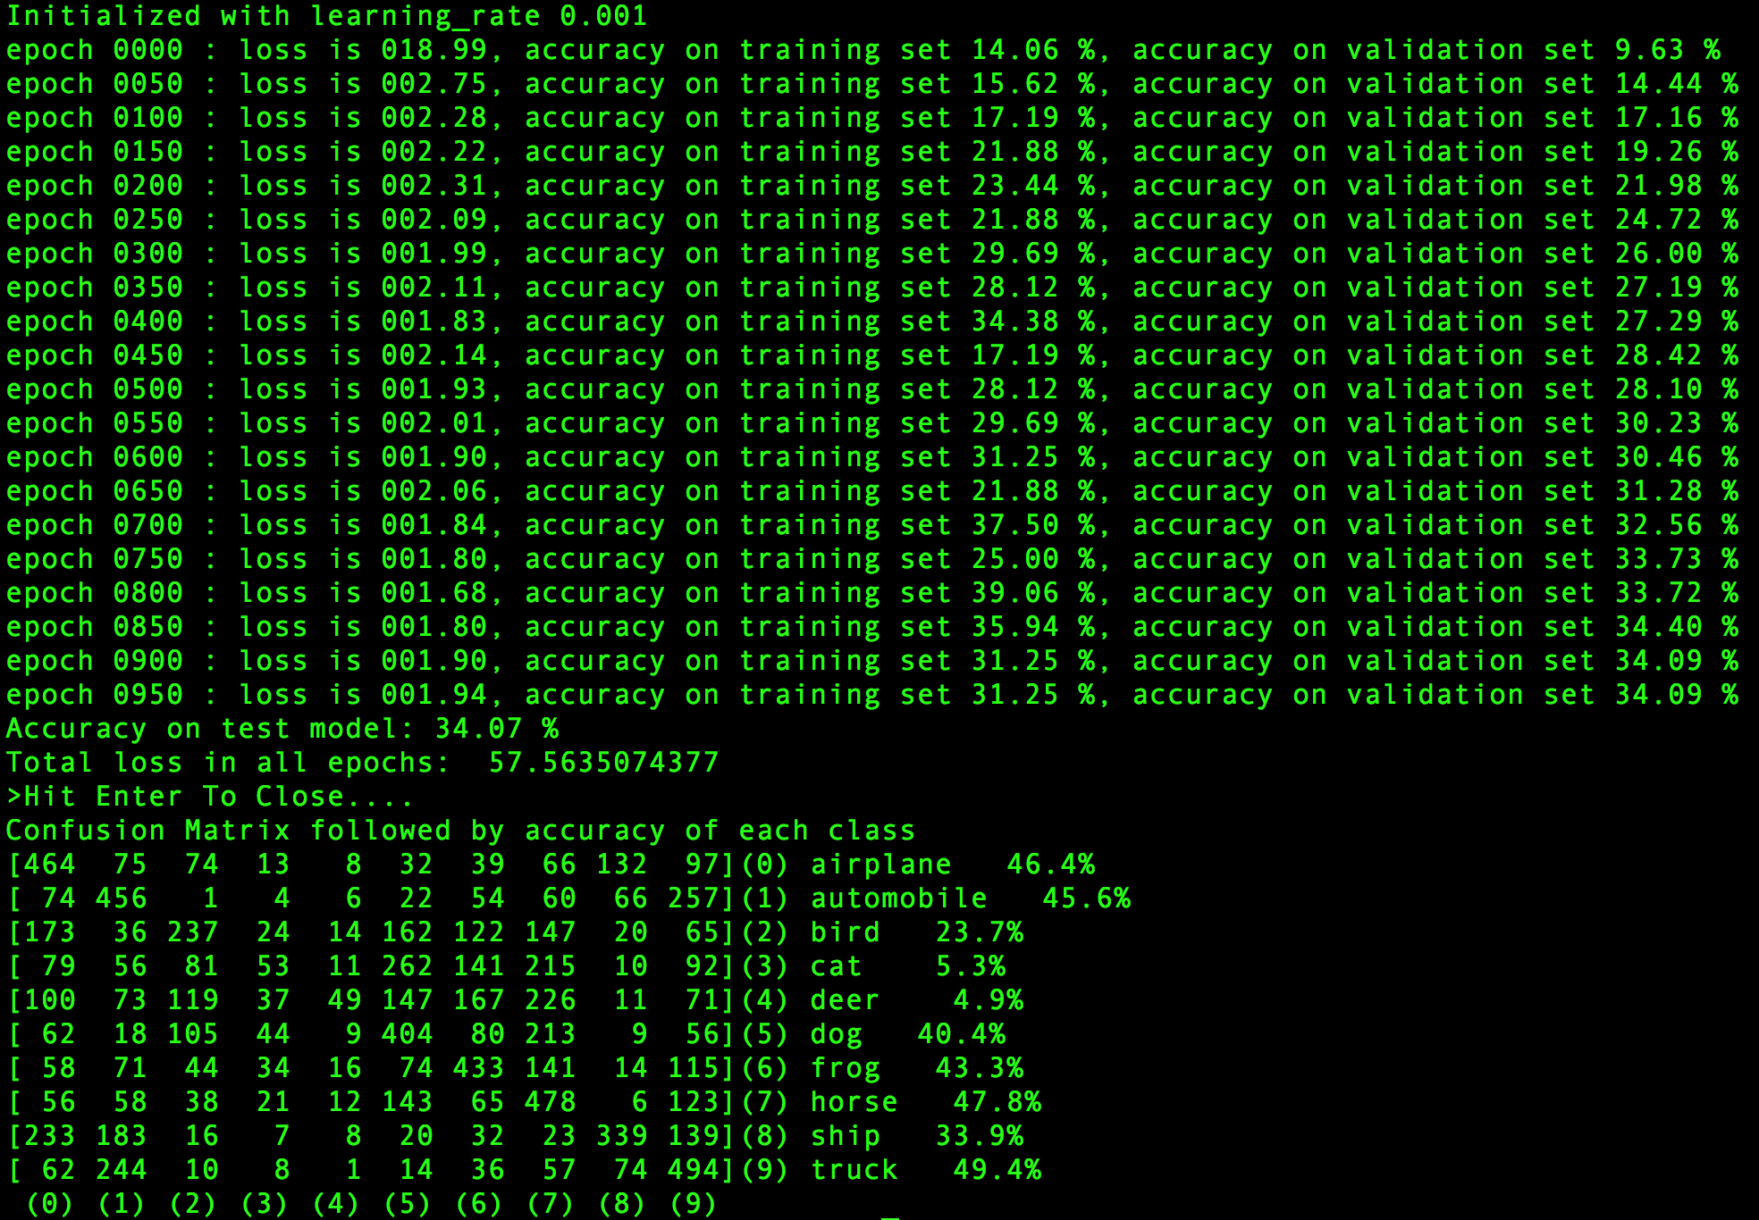

## First layer is 6 and second layer is 18

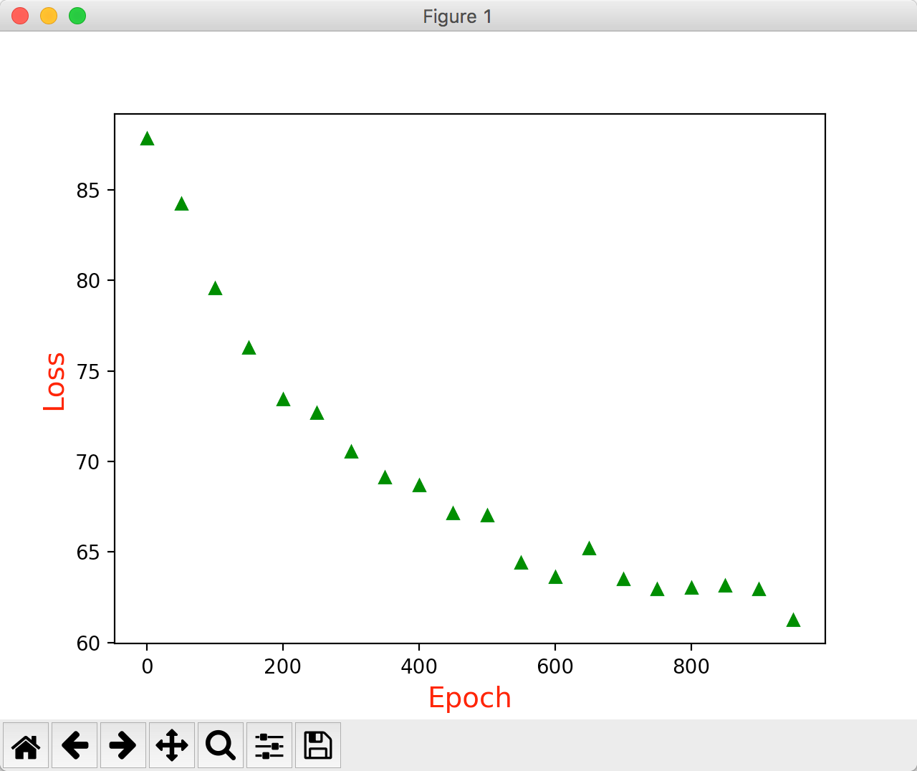

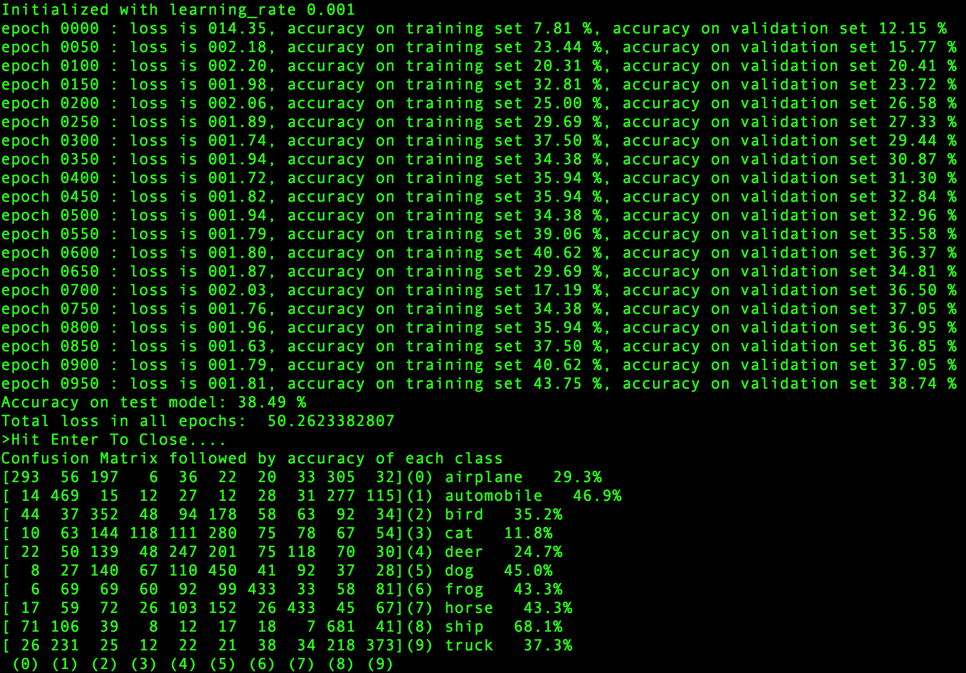

## First layer is 8 and second layer is 20

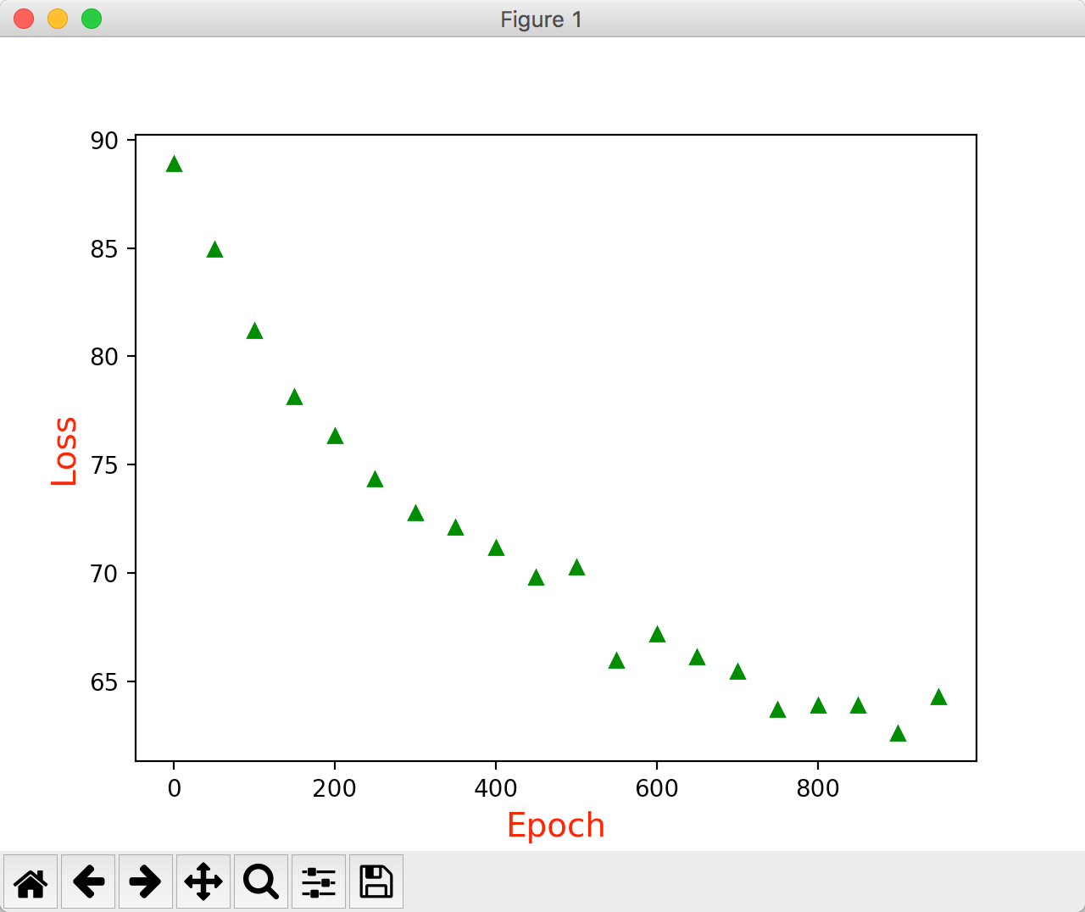

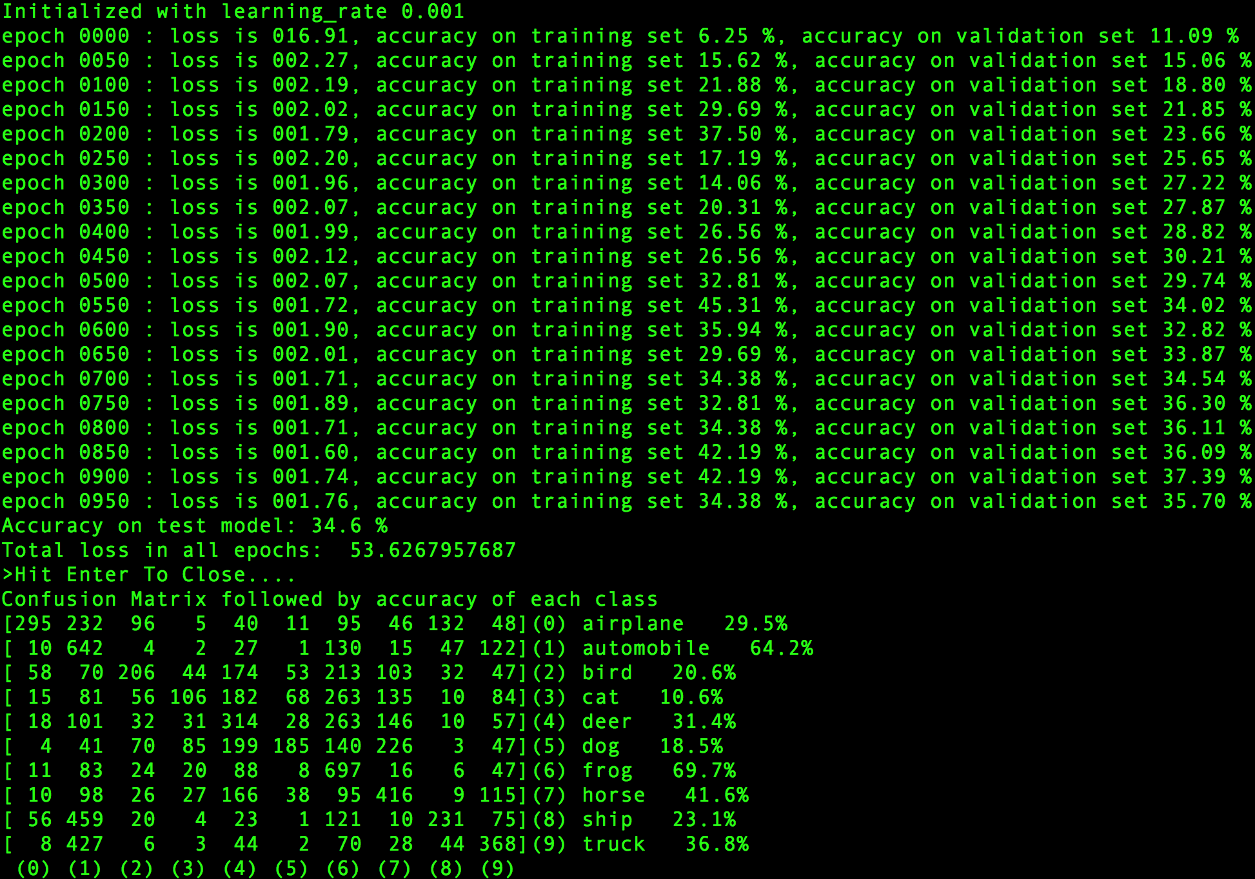

## Overall Performance

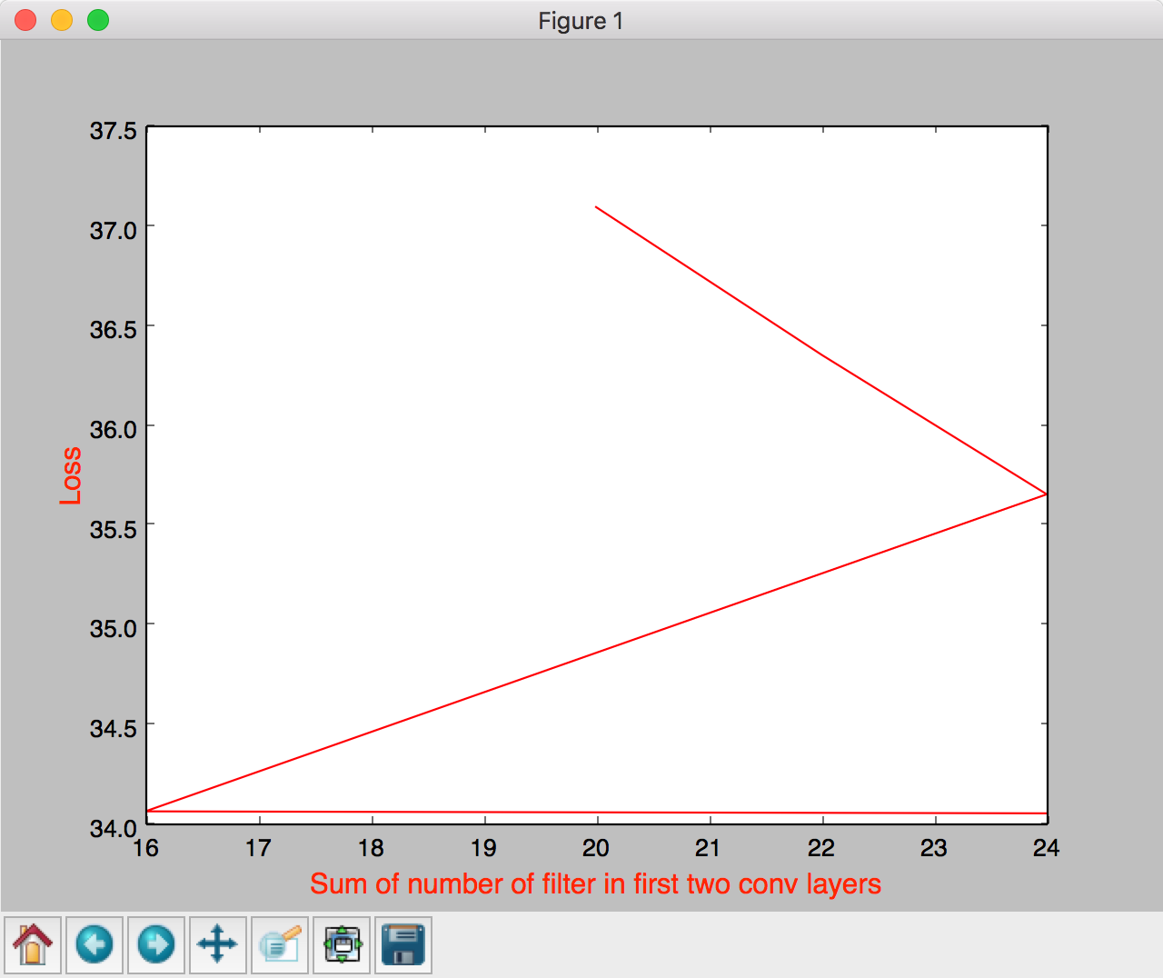

# Varying size of fully connected Layers

Constant

Learning constant: 0.001. First layer has 6 5x5 filters and second layer has 16 5x5 filters as mentioned in the homework assignment. Epoch = 1000

## 1.) Both fully connected layers of size 50

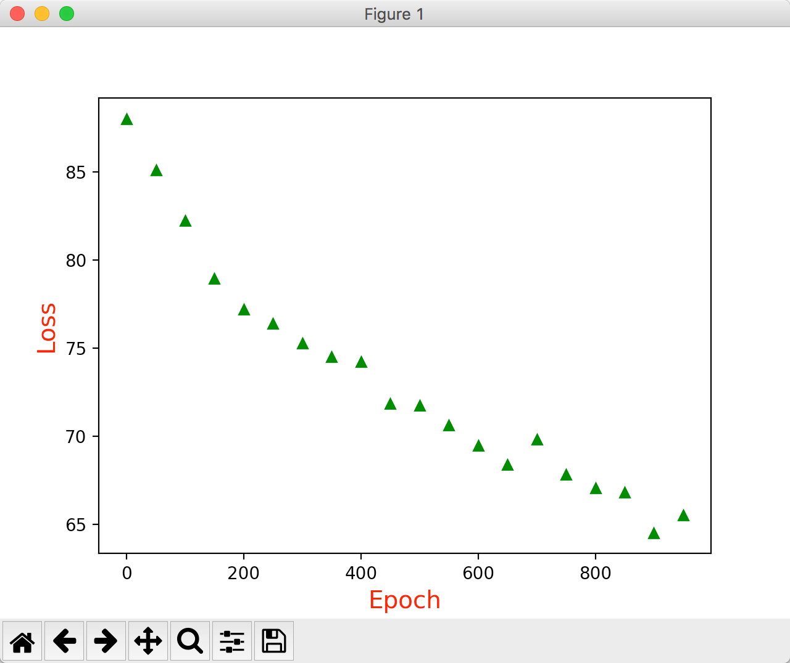

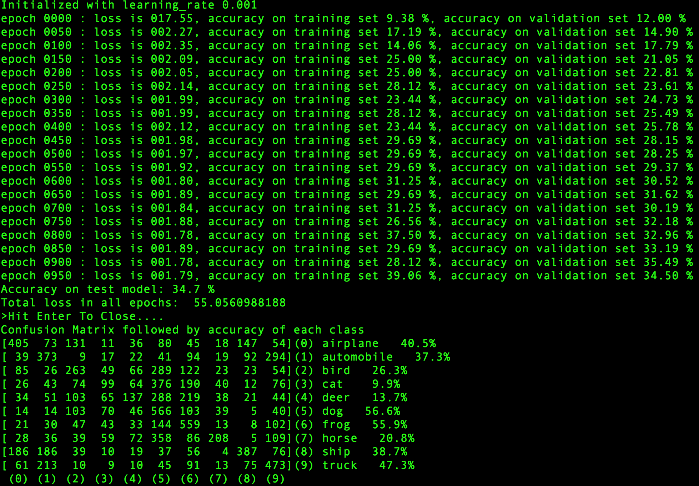

2.) Fully connected Layer 1 = 50 and Fully connected Layer 2 = 100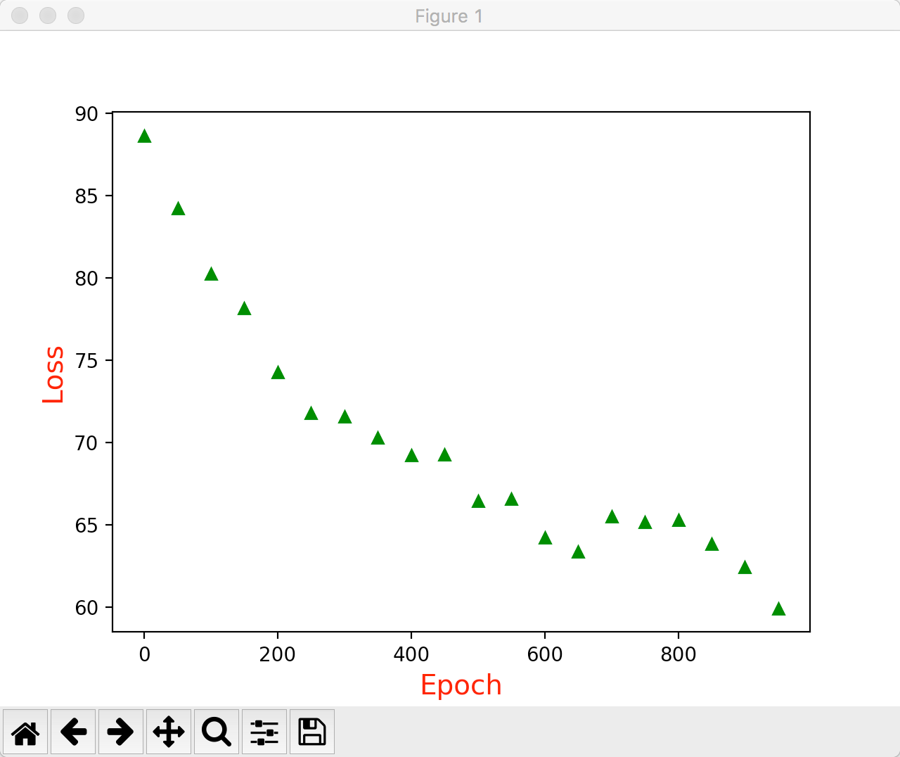

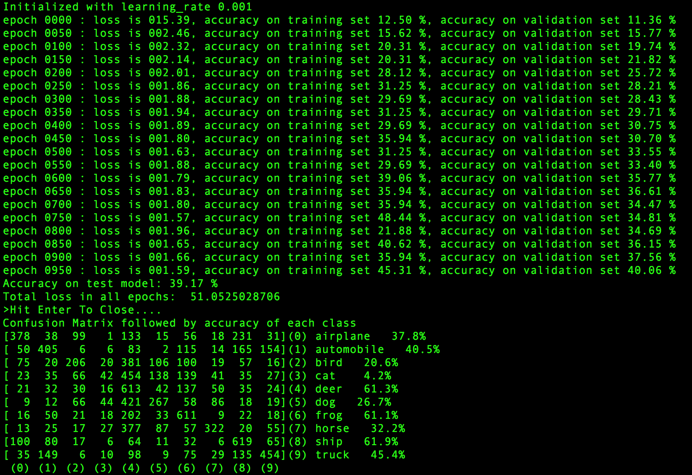

## 3.) Fully connected layer 1 = 100 and fully connected layer 2 = 50deepika:private:var:folders:vs:41q3b56n323dlcj_3jz6f8j00000gn:T:DMD1F991F12-98D9-4828-B805-ACC56B4C57B0:Figure_1.png

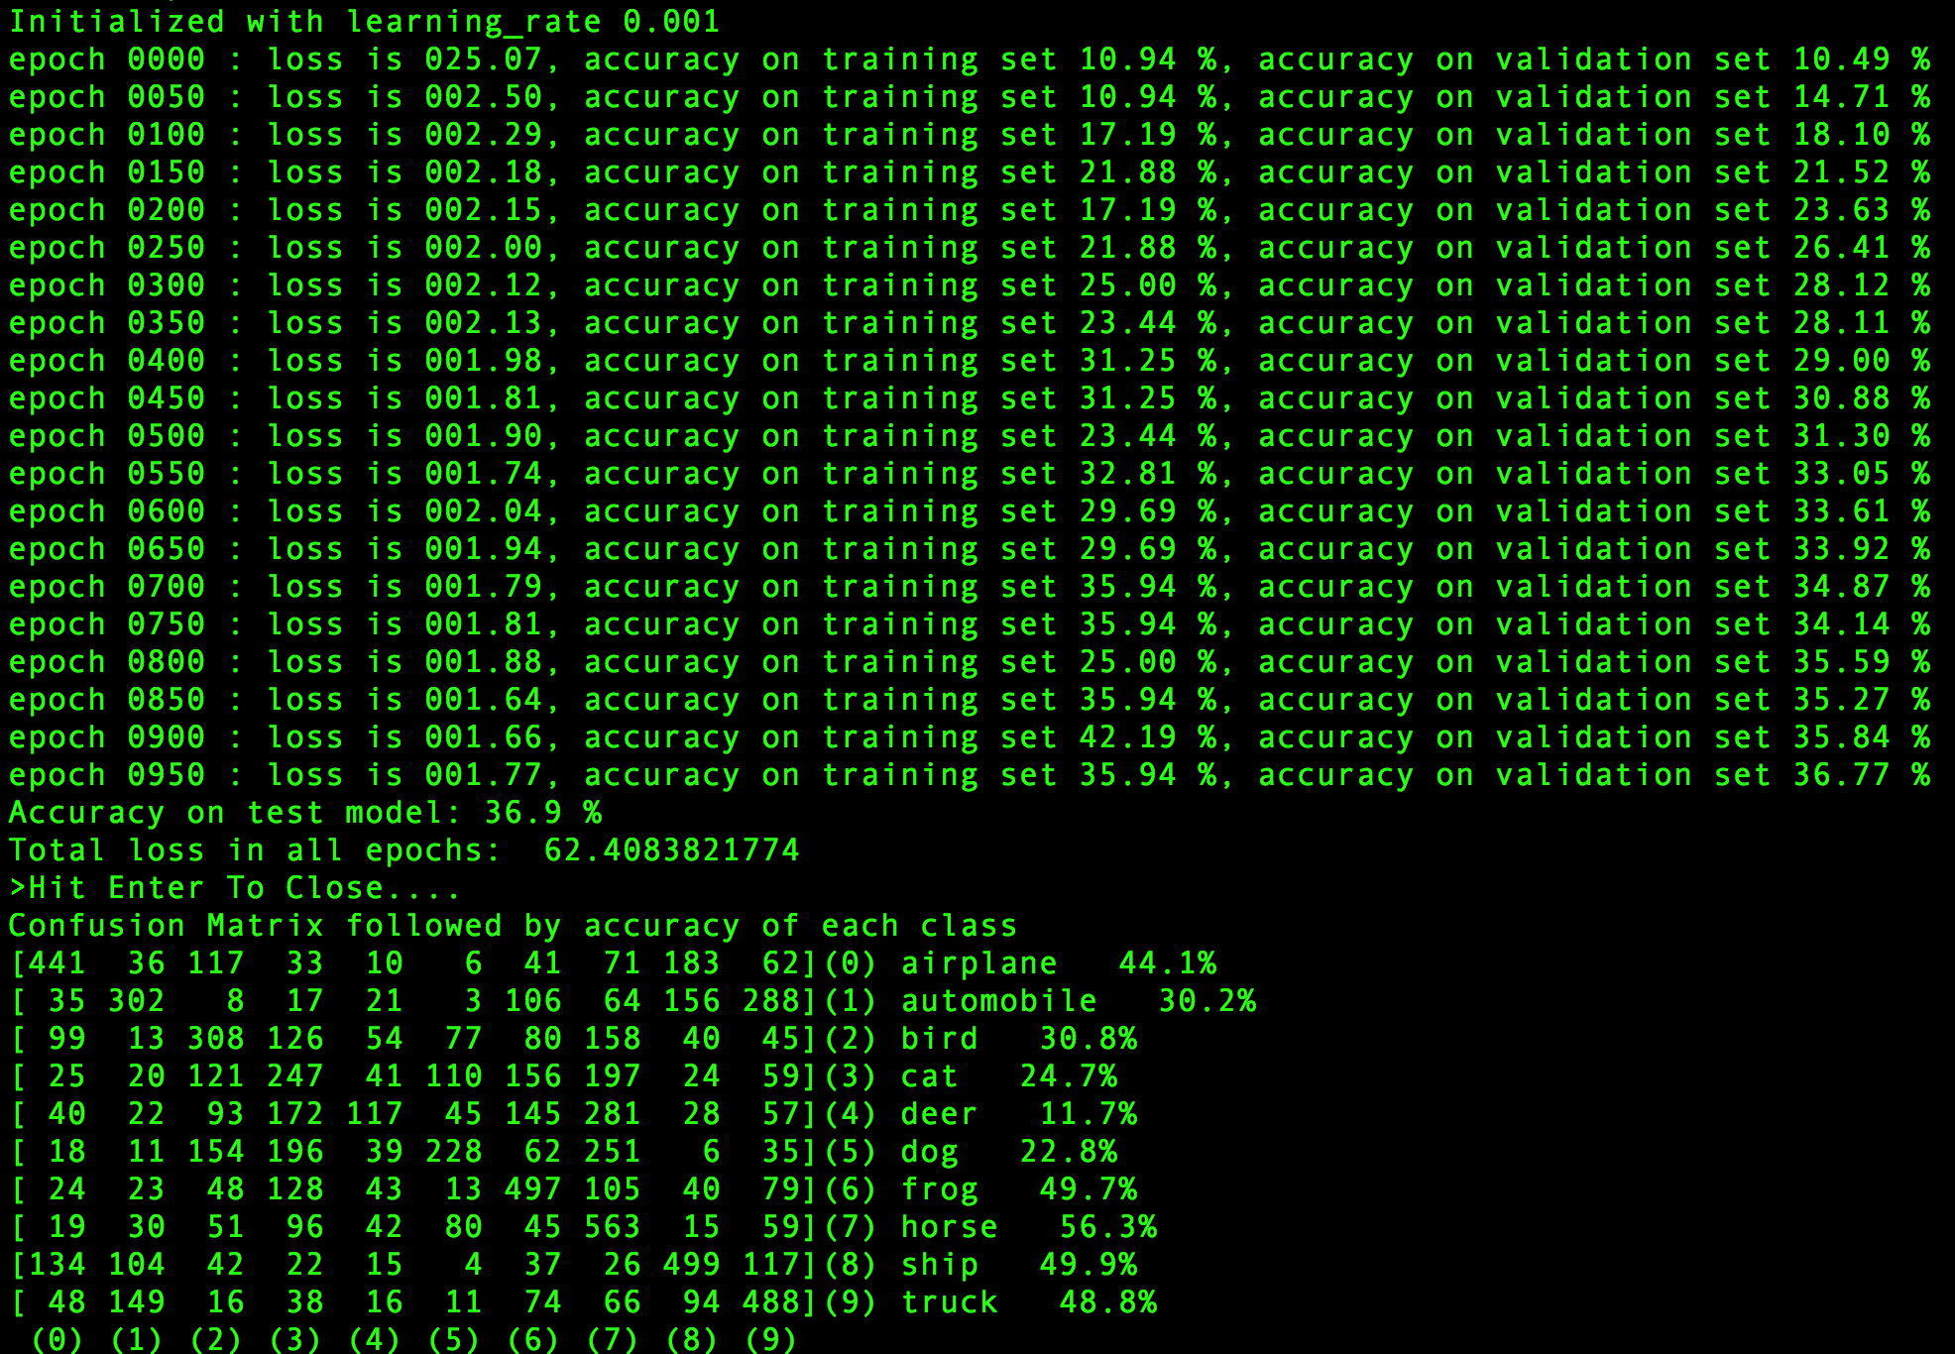

## 4.) Fully connected layer 1 = 150 and fully connected layer 2 = 150

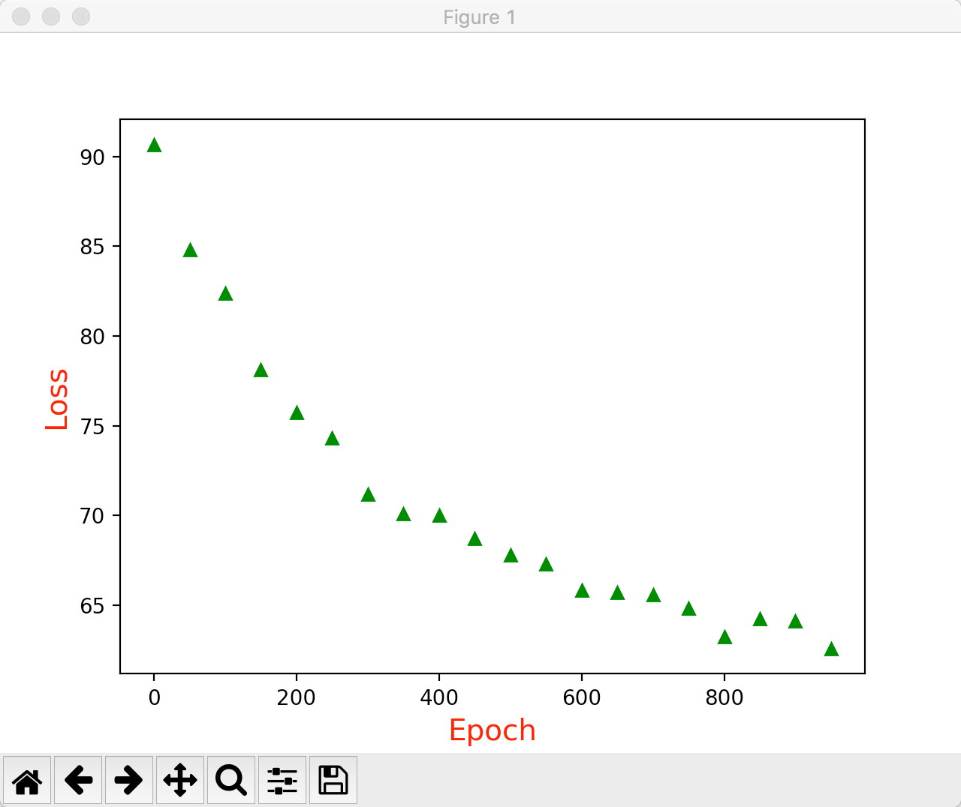

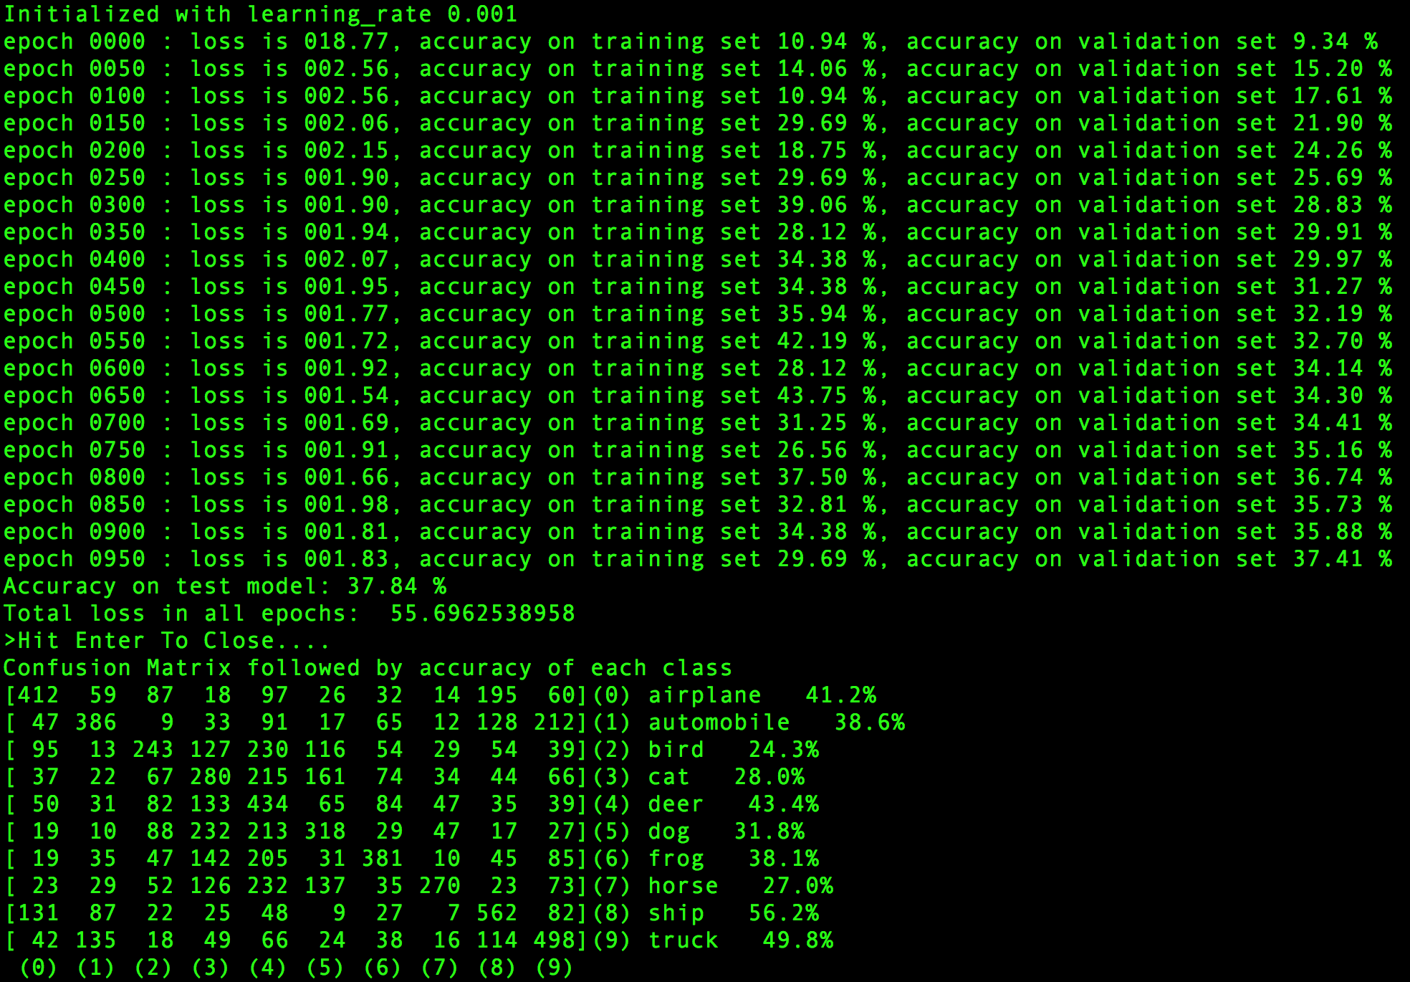

## Fully connected layer 1 = 120 and fully connected layer 2 = 84





## Fully connected layer 1 = 200 and fully connected layer 2 = 200

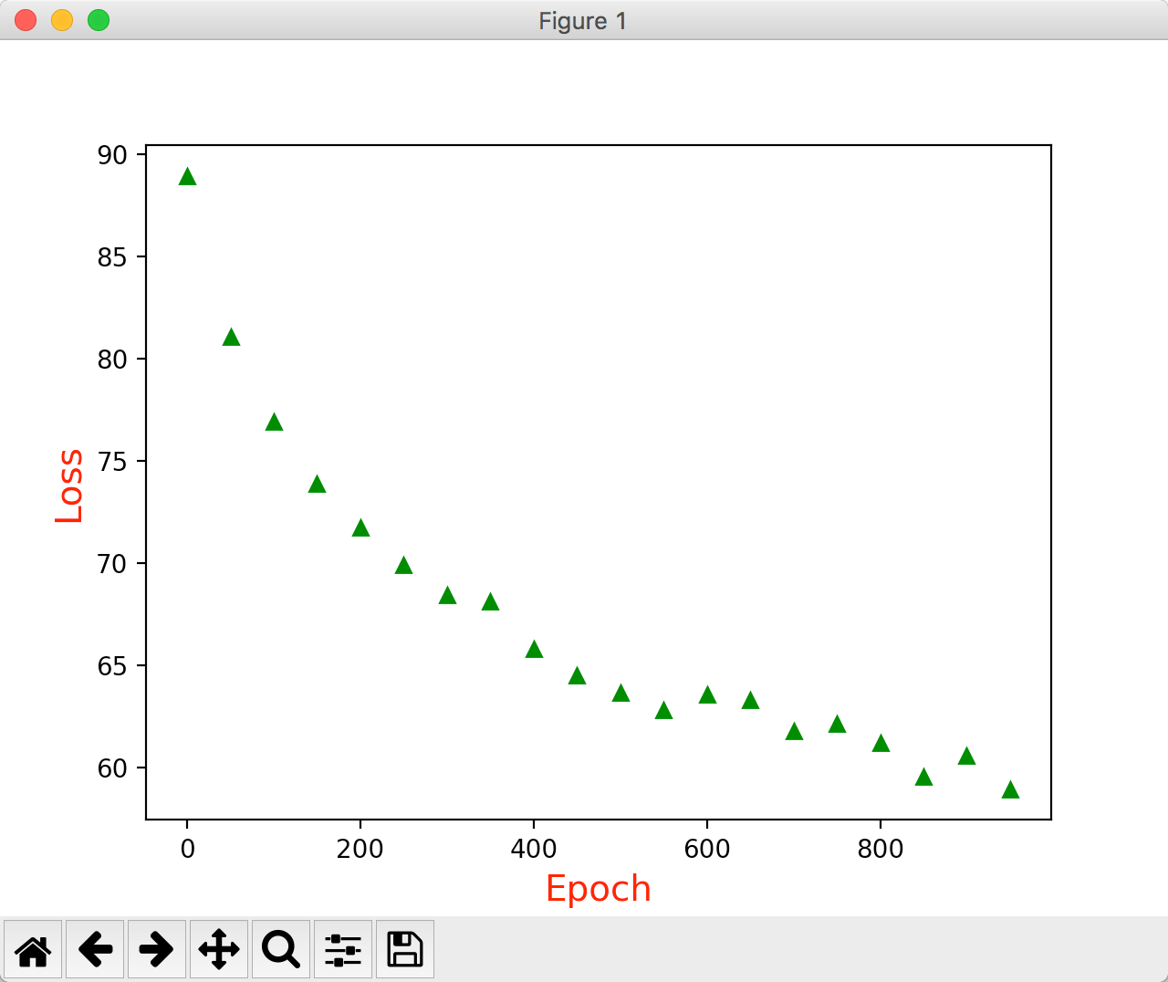

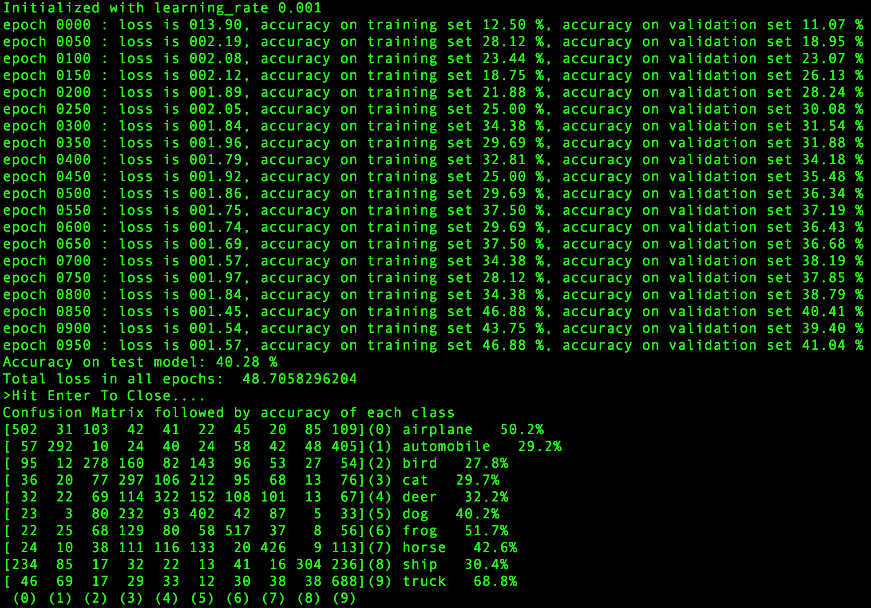

## Overall Performance

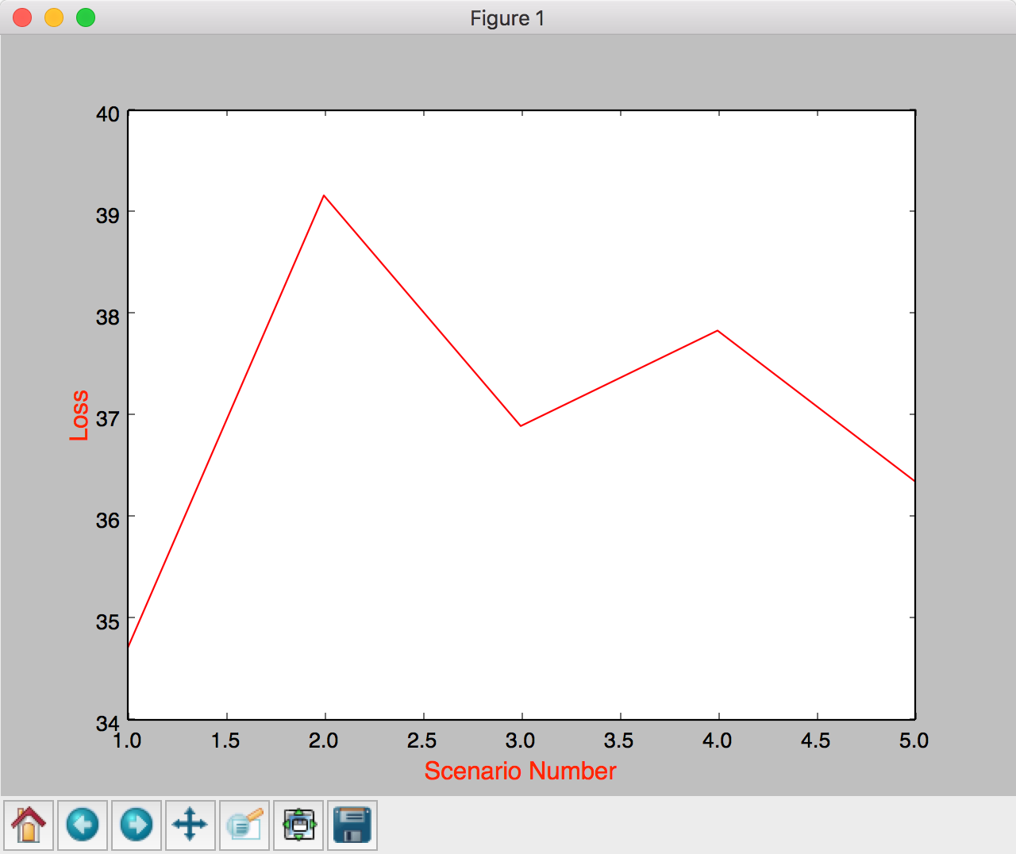

# Varying the regularizer

Constants: All layers as mentioned in homework assignment. Epoch = 1000 and learning rate = 0.001

## 1.) Weight decay = 1e-8

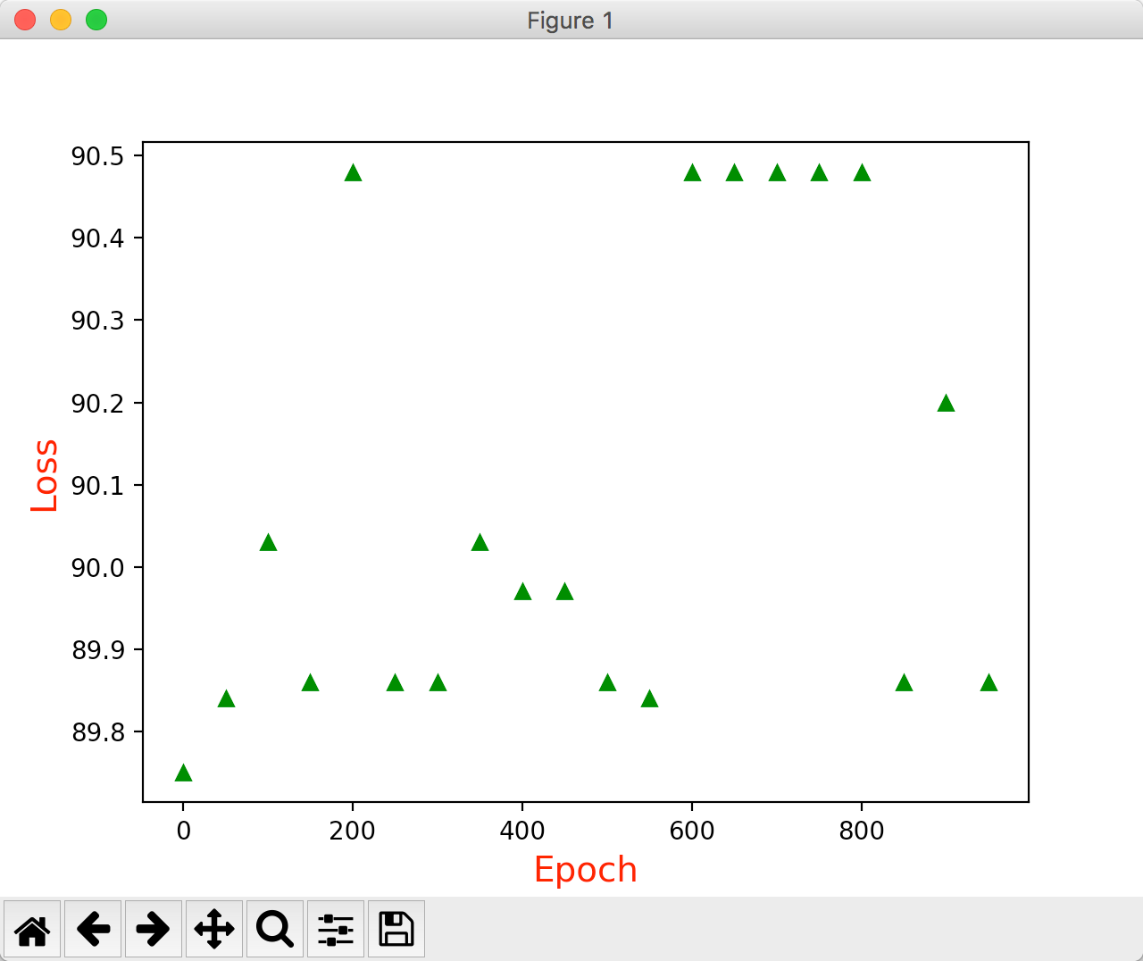

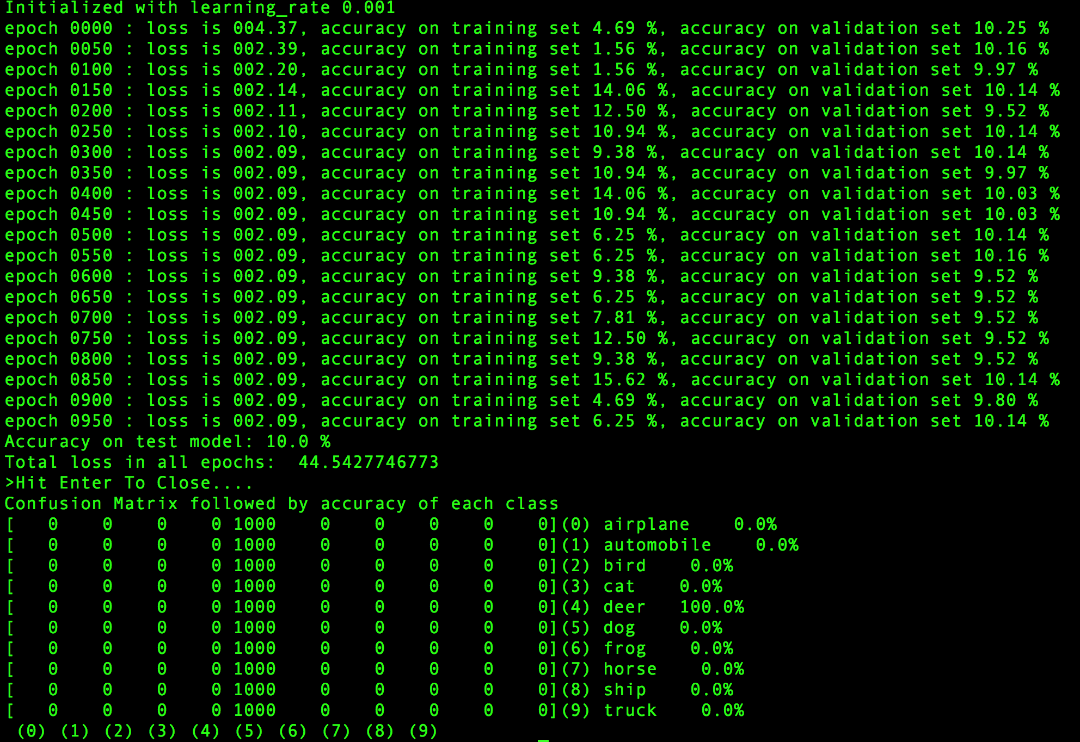

## 2.) Weight decay = 1e-10

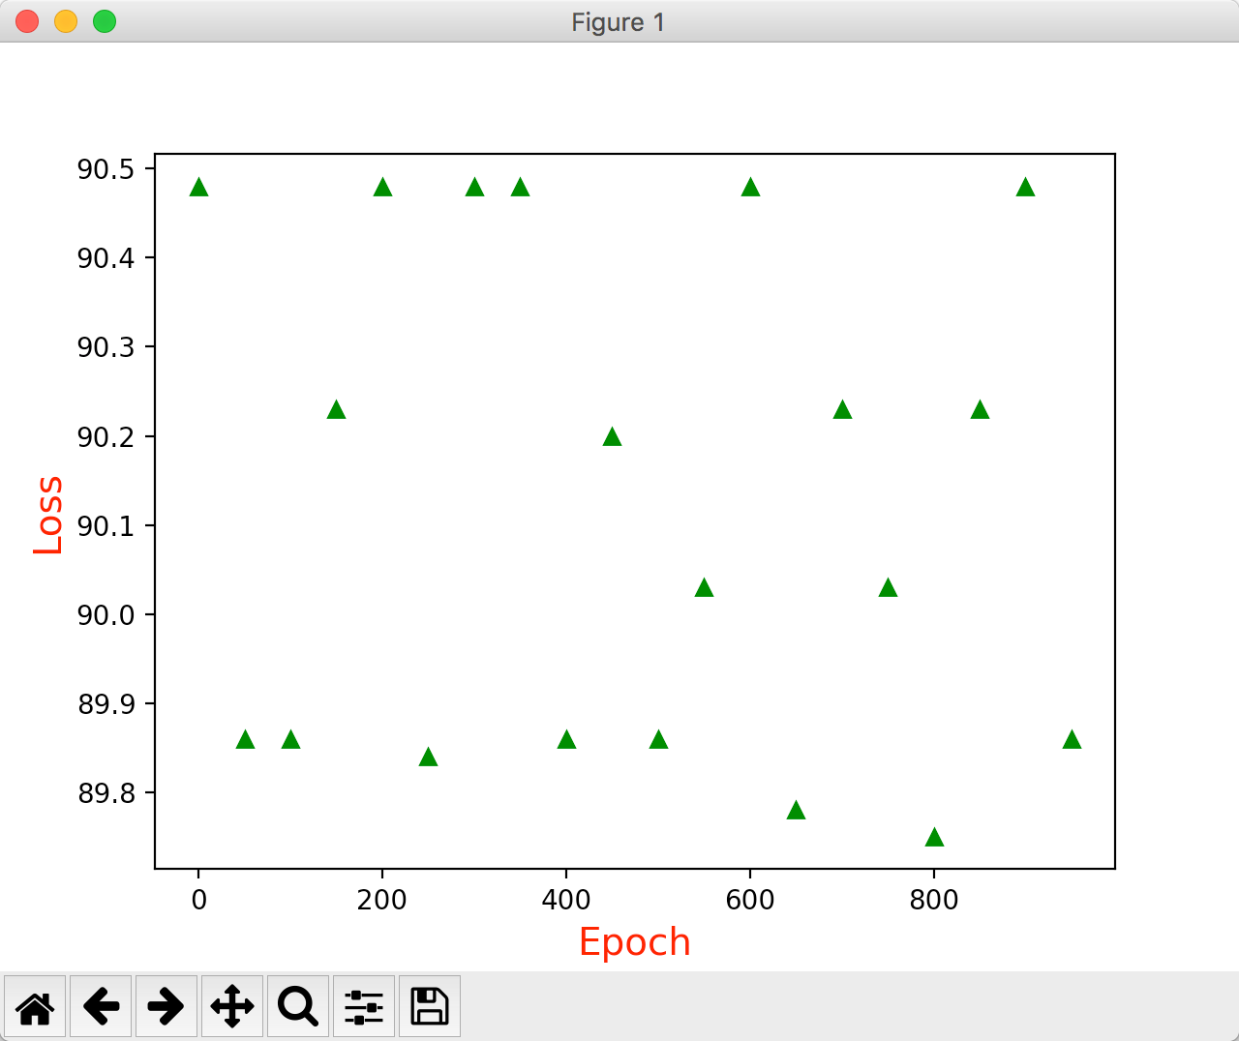

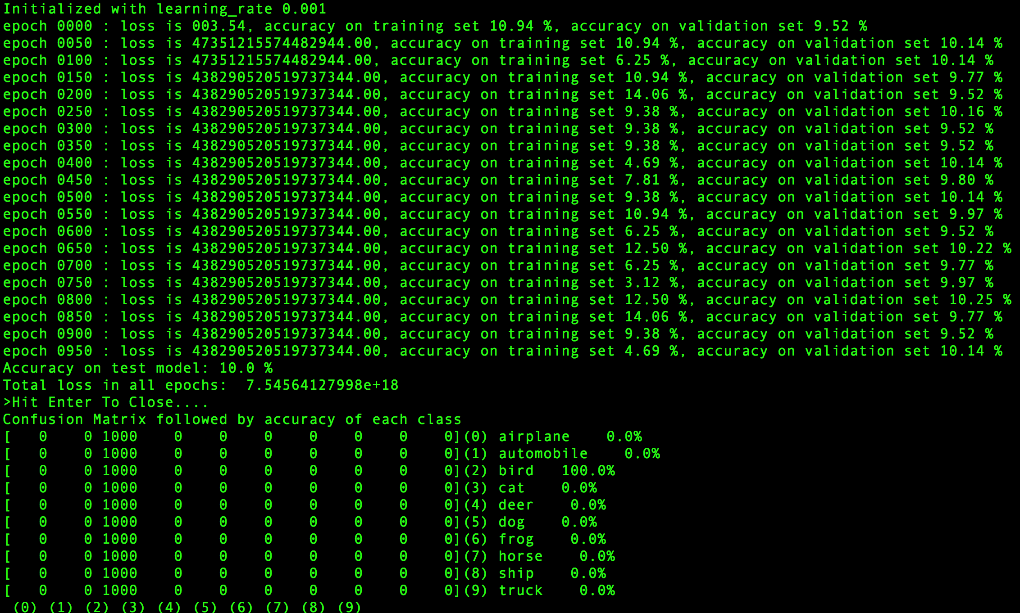

## 3.) Weight decay = 1e-15

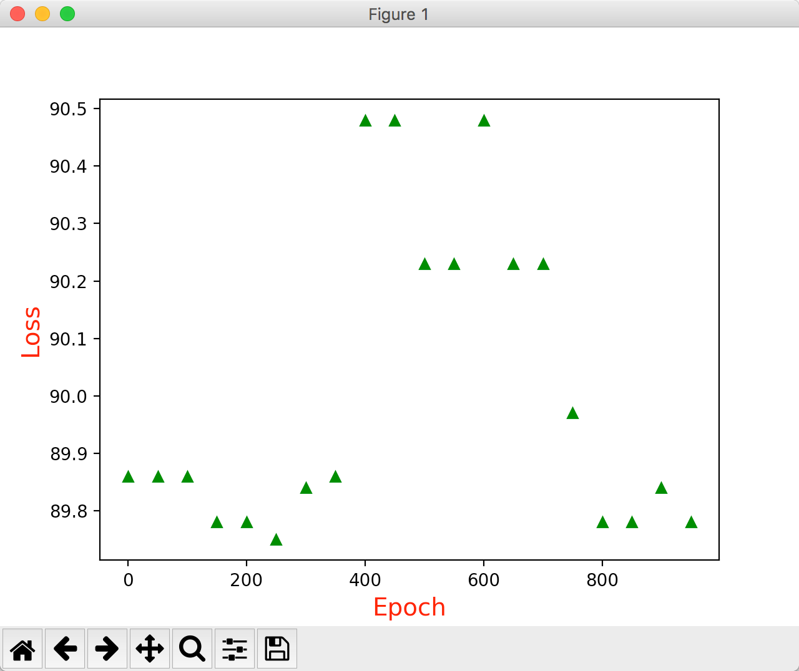

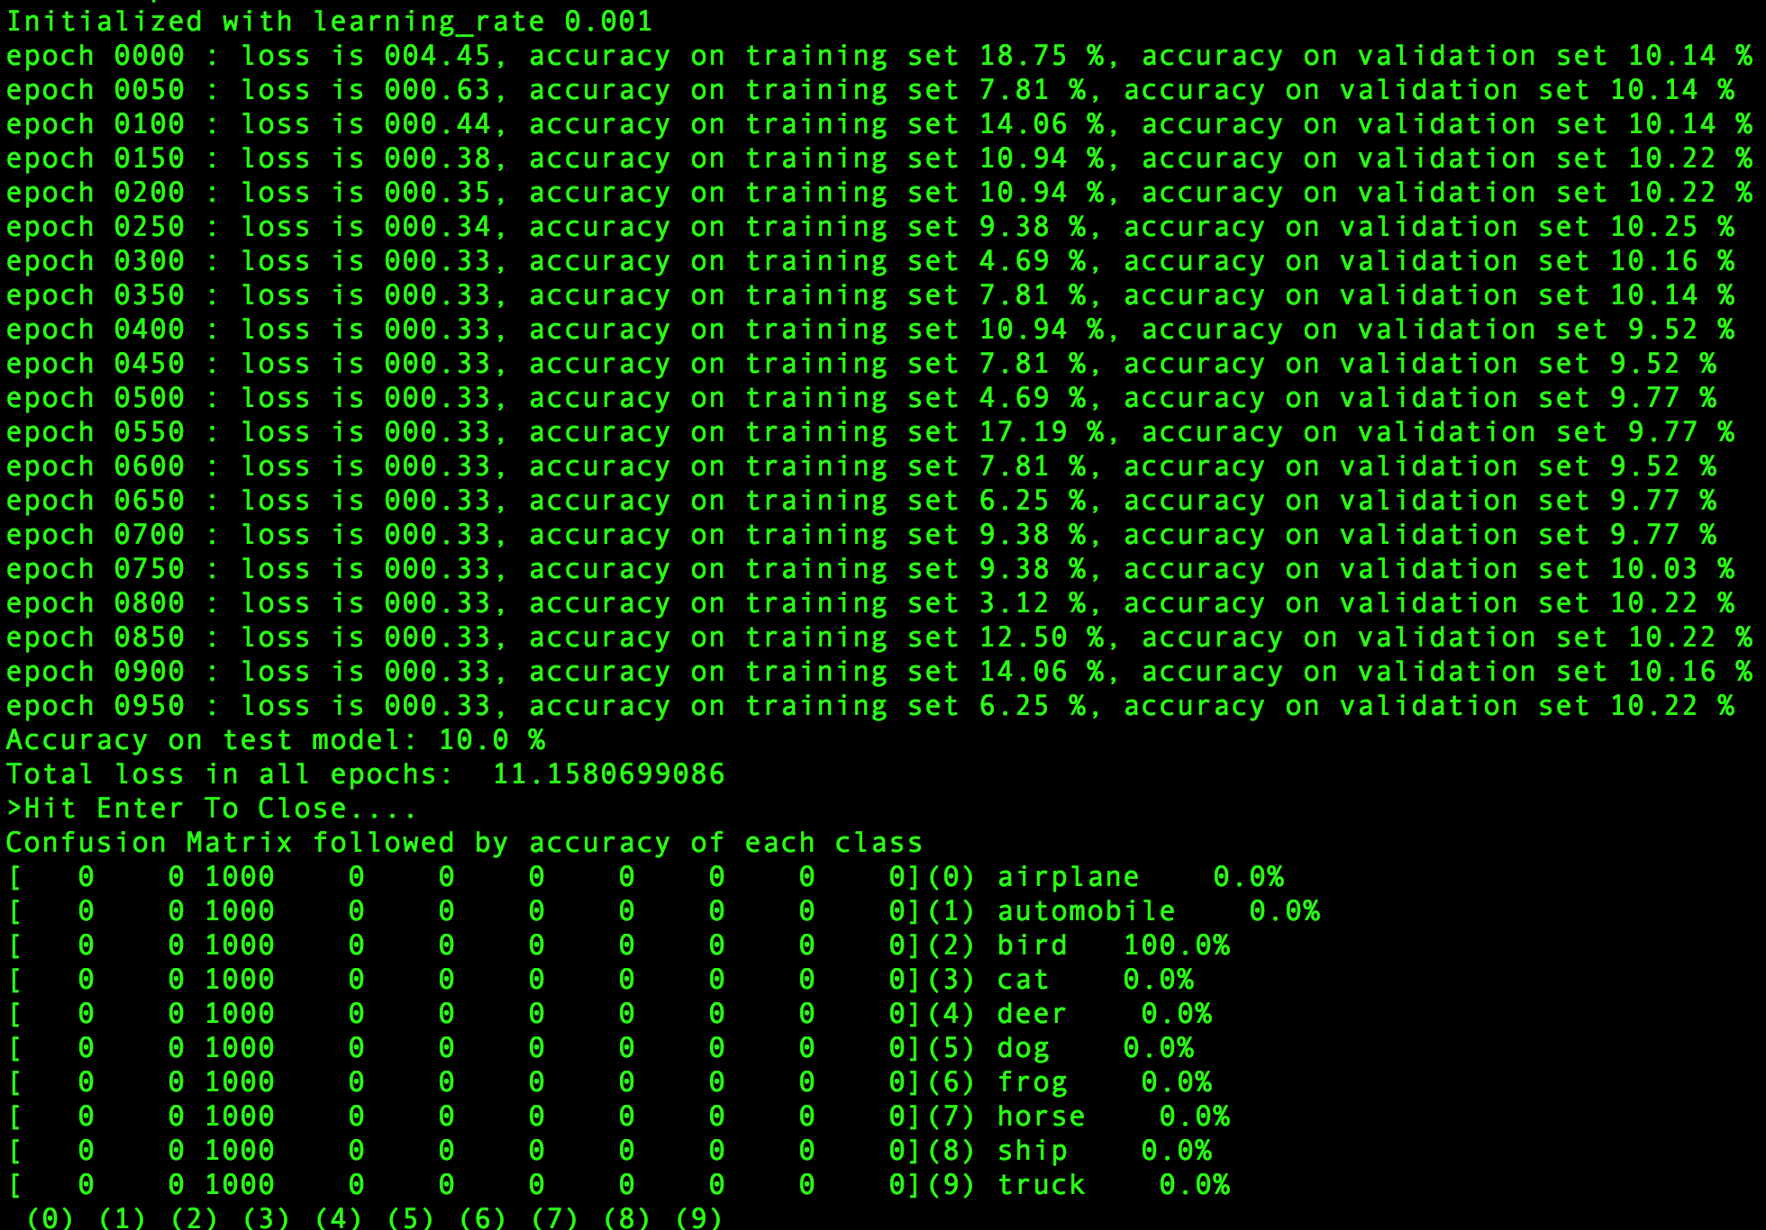

## 4.) Weight decay = 0.00001

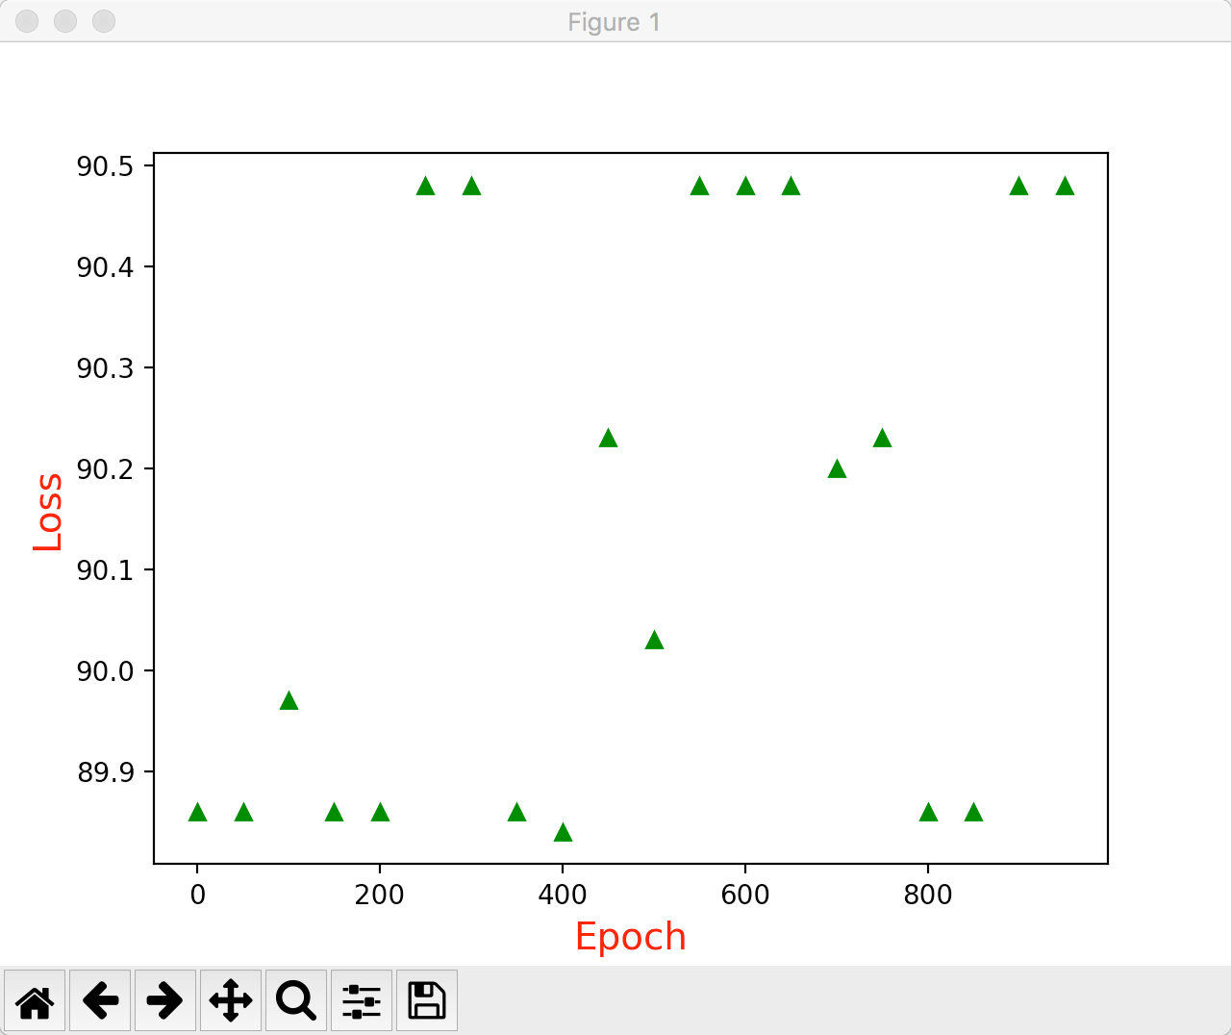

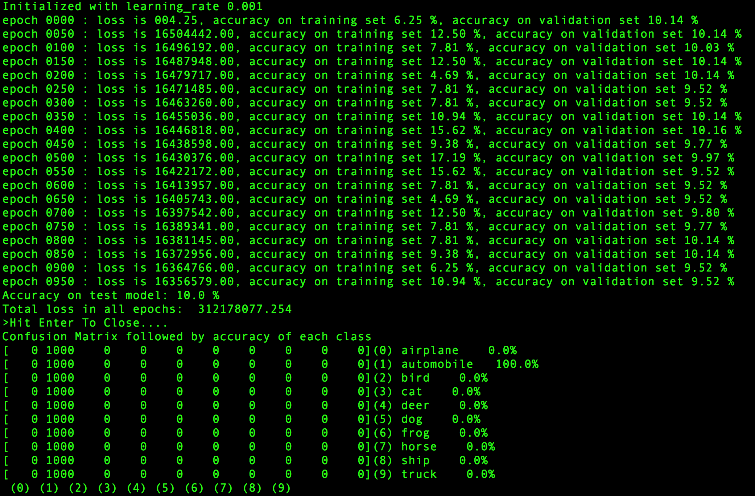

# My Comments

Varying various parameters results in interesting values. It is just that increasing a particular value can not keep increasing the accuracy or lower the loss beyond a particular value. That is investing beyond that point isn’t valuable as drop in loss will be less than 1% or so.

The same case is observed in almost every variation. If I keep increasing number of filters in a particular layer then accuracy increases to a point and then it starts decreasing. In the assignment, I varied various parameters such as filter size, number of filters, regularizer etc. and in each case I observed that accuracy marginally increased beyond a point.

# Source Code

\_\_author\_\_ = **'deepika'  
  
import** numpy **as** np  
**import** pickle  
**import** tensorflow **as** tf  
**from** sklearn.metrics **import** confusion\_matrix  
**import** matplotlib.pyplot **as** plt  
**import** cv2  
  
  
cifar10\_folder = **'./cifar10/'**train\_datasets = [**'data\_batch\_1'**, **'data\_batch\_2'**, **'data\_batch\_3'**, **'data\_batch\_4'** ]  
test\_dataset = [**'test\_batch'**]  
validation\_dataset = [**'data\_batch\_5'**]  
c10\_image\_height = 31  
c10\_image\_width = 31  
c10\_image\_depth = 1  
c10\_num\_labels = 10  
c10\_image\_size = 32  
  
**def** handleAugmentation(np\_dataset\_, image\_width, image\_height, image\_depth):  
 new\_dataset = []  
 **for** image **in** np\_dataset\_:  
 height, width = image.shape[0], image.shape[1]  
 *# Resize by +10%* res1 = cv2.resize(image,( int(height + 0.1 \* height), int(width + 0.1 \* width)),interpolation=cv2.INTER\_CUBIC)  
  
 *#Crop 90% from all 4 corners* crop\_perc = 0.9  
  
 roi\_size = [  
 int(res1.shape[0] \* crop\_perc), int(res1.shape[1] \* crop\_perc)  
 ]  
 roi\_tl\_x = [0, res1.shape[0] - roi\_size[0]]  
 roi\_tl\_y = [0, res1.shape[1] - roi\_size[1]]  
  
 sel\_x = np.random.randint(roi\_tl\_x[0], roi\_tl\_x[1])  
 sel\_y = np.random.randint(roi\_tl\_y[0], roi\_tl\_y[1])  
 cur\_roi = [sel\_x, sel\_y, sel\_x + roi\_size[0], sel\_y + roi\_size[1]]  
 res2 = res1[cur\_roi[0]:cur\_roi[2], cur\_roi[1]:cur\_roi[3]]  
  
 *#Flip  
 # horizontal flip* res3 = cv2.flip(res2, 1)  
  
 *# vertical flip* res3 = cv2.flip(res3, 0)  
  
 *# all flip* res3 = cv2.flip(res3, -1)  
 *#print "res3.shape", res3.shape* new\_dataset.append(res3)  
  
 new\_dataset = np.array([np.array(image\_data).reshape(31, 31, image\_depth) **for** image\_data **in** new\_dataset])  
 **return** new\_dataset  
  
**def** randomize(dataset, labels):  
 permutation = np.random.permutation(labels.shape[0])  
 shuffled\_dataset = dataset[permutation, :, :]  
 shuffled\_labels = labels[permutation]  
 **return** shuffled\_dataset, shuffled\_labels  
  
**def** one\_hot\_encode(np\_array):  
 **return** (np.arange(10) == np\_array[:,None]).astype(np.float32)  
  
**def** reformat\_data(dataset, labels, image\_width, image\_height, image\_depth):  
 grayscale = 0.21\*dataset[:,0:1024] + 0.72\*dataset[:,1024:2048] + 0.07\*dataset[:,2048:3072]  
  
 np\_dataset\_ = np.array([np.array(image\_data).reshape(image\_width, image\_height, image\_depth) **for** image\_data **in** grayscale])  
 np\_dataset\_ = np\_dataset\_ - np\_dataset\_.mean(axis=1, keepdims=True)  
 np\_dataset\_ = handleAugmentation(np\_dataset\_, image\_width, image\_height, image\_depth)  
 np\_labels\_ = one\_hot\_encode(np.array(labels, dtype=np.float32))  
 np\_dataset, np\_labels = randomize(np\_dataset\_, np\_labels\_)  
 **return** np\_dataset, np\_labels  
  
**def** flatten\_tf\_array(array):  
 shape = array.get\_shape().as\_list()  
 **return** tf.reshape(array, [shape[0], shape[1] \* shape[2] \* shape[3]])  
  
**def** accuracy(predictions, labels):  
 **return** (100.0 \* np.sum(np.argmax(predictions, 1) == np.argmax(labels, 1)) / predictions.shape[0])  
  
  
**with** open(cifar10\_folder + validation\_dataset[0], **'rb'**) **as** f0:  
 c10\_validation\_dict = pickle.load(f0)  
  
c10\_validation\_dataset, c10\_validation\_labels = c10\_validation\_dict[**b'data'**], c10\_validation\_dict[**b'labels'**]  
validation\_dataset\_cifar10, validation\_labels\_cifar10 = reformat\_data(c10\_validation\_dataset, c10\_validation\_labels, c10\_image\_size, c10\_image\_size, c10\_image\_depth)  
  
**with** open(cifar10\_folder + test\_dataset[0], **'rb'**) **as** f0:  
 c10\_test\_dict = pickle.load(f0)  
  
c10\_test\_dataset, c10\_test\_labels = c10\_test\_dict[**b'data'**], c10\_test\_dict[**b'labels'**]  
test\_dataset\_cifar10, test\_labels\_cifar10 = reformat\_data(c10\_test\_dataset, c10\_test\_labels, c10\_image\_size, c10\_image\_size, c10\_image\_depth)  
  
c10\_train\_dataset, c10\_train\_labels = [], []  
**for** train\_dataset **in** train\_datasets:  
 **with** open(cifar10\_folder + train\_dataset, **'rb'**) **as** f0:  
 c10\_train\_dict = pickle.load(f0)  
 c10\_train\_dataset\_, c10\_train\_labels\_ = c10\_train\_dict[**b'data'**], c10\_train\_dict[**b'labels'**]  
  
 c10\_train\_dataset.append(c10\_train\_dataset\_)  
 c10\_train\_labels += c10\_train\_labels\_  
  
c10\_train\_dataset = np.concatenate(c10\_train\_dataset, axis=0)  
train\_dataset\_cifar10, train\_labels\_cifar10 = reformat\_data(c10\_train\_dataset, c10\_train\_labels, c10\_image\_size, c10\_image\_size, c10\_image\_depth)  
**del** c10\_train\_dataset  
**del** c10\_train\_labels  
 *########################  
# Neural Net  
########################*LENET5\_BATCH\_SIZE = 32  
LENET5\_PATCH\_SIZE = 5  
LENET5\_PATCH\_DEPTH\_1 = 8  
LENET5\_PATCH\_DEPTH\_2 = 16  
LENET5\_NUM\_HIDDEN\_1 = 120 *#120*LENET5\_NUM\_HIDDEN\_2 = 84 *#84***def** variables\_lenet5(patch\_size = LENET5\_PATCH\_SIZE, patch\_depth1 = LENET5\_PATCH\_DEPTH\_1,  
 patch\_depth2 = LENET5\_PATCH\_DEPTH\_2,  
 num\_hidden1 = LENET5\_NUM\_HIDDEN\_1, num\_hidden2 = LENET5\_NUM\_HIDDEN\_2,  
 image\_depth = 1, num\_labels = 10):  
  
 xavier = tf.contrib.layers.xavier\_initializer()  
 w1 = tf.get\_variable(**"w1"**, shape=[patch\_size, patch\_size, image\_depth, patch\_depth1], initializer=xavier)  
 b1 = tf.Variable(tf.zeros([patch\_depth1]))  
  
 w2 = tf.get\_variable(**"w2"**, shape=[patch\_size, patch\_size, patch\_depth1, patch\_depth2], initializer=xavier)  
 b2 = tf.Variable(tf.constant(1.0, shape=[patch\_depth2]))  
  
 w3 = tf.get\_variable(**"w3"**, shape=[4\*4\*patch\_depth2, num\_hidden1], initializer=xavier)  
 b3 = tf.Variable(tf.constant(1.0, shape = [num\_hidden1]))  
  
 w4 = tf.get\_variable(**"w4"**, shape=[num\_hidden1, num\_hidden2], initializer=xavier)  
 b4 = tf.Variable(tf.constant(1.0, shape = [num\_hidden2]))  
  
 w5 = tf.get\_variable(**"w5"**, shape=[num\_hidden2, num\_labels],initializer=xavier)  
 b5 = tf.Variable(tf.constant(1.0, shape = [num\_labels]))  
 variables = {  
 **'w1'**: w1, **'w2'**: w2, **'w3'**: w3, **'w4'**: w4, **'w5'**: w5,  
 **'b1'**: b1, **'b2'**: b2, **'b3'**: b3, **'b4'**: b4, **'b5'**: b5  
 }  
 **return** variables  
  
**def** model\_lenet5(data, variables):  
 layer1\_conv = tf.nn.conv2d(data, variables[**'w1'**], [1, 1, 1, 1], padding=**'VALID'**) + variables[**'b1'**]  
 layer1\_conv = tf.nn.relu(layer1\_conv)  
  
 layer1\_pool = tf.nn.max\_pool(layer1\_conv, [1, 2, 2, 1], [1, 2, 2, 1], padding=**'VALID'**)  
  
 layer2\_conv = tf.nn.conv2d(layer1\_pool, variables[**'w2'**], [1, 1, 1, 1], padding=**'VALID'**) + variables[**'b2'**]  
 layer2\_conv = tf.nn.relu(layer2\_conv)  
  
 layer2\_pool = tf.nn.max\_pool(layer2\_conv, [1, 2, 2, 1], [1, 2, 2, 1], padding=**'VALID'**)  
  
 flat\_layer = flatten\_tf\_array(layer2\_pool)  
  
 layer3\_fccd = tf.matmul(flat\_layer, variables[**'w3'**]) + variables[**'b3'**]  
 layer3\_actv = tf.nn.relu(layer3\_fccd)  
  
 layer4\_fccd = tf.matmul(layer3\_actv, variables[**'w4'**]) + variables[**'b4'**]  
 layer4\_actv = tf.nn.relu(layer4\_fccd)  
  
 logits = tf.matmul(layer4\_actv, variables[**'w5'**]) + variables[**'b5'**]  
 **return** logits  
  
*# Run the model  
# parameters determining the model size*image\_size = 32  
num\_labels = 10  
  
*#the datasets*train\_dataset = train\_dataset\_cifar10  
train\_labels = train\_labels\_cifar10  
test\_dataset = test\_dataset\_cifar10  
test\_labels = test\_labels\_cifar10  
validation\_dataset = validation\_dataset\_cifar10  
validation\_labels = validation\_labels\_cifar10  
  
*#number of iterations and learning rate*display\_step = 50  
learning\_rate = 0.001  
batch\_size = 64  
num\_steps = 1000  
  
graph = tf.Graph()  
**with** graph.as\_default():  
 *#1) First we put the input data in a tensorflow friendly form.* tf\_train\_dataset = tf.placeholder(tf.float32, shape=(batch\_size, c10\_image\_width, c10\_image\_height, c10\_image\_depth))  
 tf\_train\_labels = tf.placeholder(tf.float32, shape = (batch\_size, num\_labels))  
 tf\_test\_dataset = tf.constant(test\_dataset, tf.float32)  
 tf\_validation\_dataset = tf.constant(validation\_dataset, tf.float32)  
  
 *#2) Then, the weight matrices and bias vectors are initialized* variables = variables\_lenet5(image\_depth = c10\_image\_depth, num\_labels = num\_labels)  
  
 *#3. The model used to calculate the logits (predicted labels)* model = model\_lenet5  
 logits = model(tf\_train\_dataset, variables)  
  
 *#4. then we compute the softmax cross entropy between the logits and the (actual) labels  
 #regularizer = tf.contrib.layers.l2\_regularizer(scale=0.00001)  
 #reg\_term = tf.contrib.layers.apply\_regularization(regularizer, tf.trainable\_variables())  
 #loss = (tf.reduce\_mean(tf.nn.sigmoid\_cross\_entropy\_with\_logits(labels=tf\_train\_labels, logits=logits)) + reg\_term)* cost = tf.reduce\_mean(tf.nn.softmax\_cross\_entropy\_with\_logits(logits=logits, labels=tf\_train\_labels))  
  
 *#5. The optimizer is used to calculate the Adam Optimizer of the cost function  
 #optimizer = tf.train.GradientDescentOptimizer(0.5).minimize(loss)* optimizer = tf.train.AdamOptimizer().minimize(cost)  
  
 *# Predictions for the training, validation, and test data.* train\_prediction = tf.nn.softmax(logits)  
 validation\_prediction = tf.nn.softmax(model(tf\_validation\_dataset, variables))  
 test\_prediction = tf.nn.softmax(model(tf\_test\_dataset, variables)) *# tf\_test\_dataset***with** tf.Session(graph=graph) **as** session:  
 tf.global\_variables\_initializer().run()  
 **print 'Initialized with learning\_rate'**, learning\_rate  
 x\_steps = []  
 y\_value = []  
  
 epoch\_loss = 0  
 **for** step **in** range(num\_steps):  
 offset = (step \* batch\_size) % (train\_labels.shape[0] - batch\_size)  
 batch\_data = train\_dataset[offset:(offset + batch\_size), :, :, :]  
 batch\_labels = train\_labels[offset:(offset + batch\_size), :]  
  
 feed\_dict = {tf\_train\_dataset : batch\_data, tf\_train\_labels : batch\_labels}  
 \_, l, predictions = session.run([optimizer, cost, train\_prediction], feed\_dict=feed\_dict)  
 train\_accuracy = accuracy(predictions, batch\_labels)  
  
 **if** step % display\_step == 0:  
 validation\_accuracy = accuracy(validation\_prediction.eval(), validation\_labels)  
 message = **"epoch {:04d} : loss is {:06.2f}, accuracy on training set {:02.2f} %, accuracy on validation set {:02.2f} %"**.format(step, l, train\_accuracy, validation\_accuracy)  
 epoch\_loss += l  
 **print** message  
 x\_steps.append(step)  
 y\_value.append(100 - validation\_accuracy)  
  
 **print "Accuracy on test model:"**, accuracy(test\_prediction.eval(), test\_labels), **"%"  
 print "Total loss in all epochs: "**, epoch\_loss  
 result\_test\_pred = test\_prediction.eval()  
 plt.ylabel(**'Loss'**, fontsize=14, color=**'red'**)  
 plt.xlabel(**'Epoch'**, fontsize=14, color=**'red'**)  
 plt.plot(x\_steps, y\_value, **'g^'**)  
 plt.show()  
 raw\_input(**">Hit Enter To Close...."**)  
 plt.close()  
  
**print "Confusion Matrix followed by accuracy of each class"**f = open(cifar10\_folder + **'batches.meta'**, **'rb'**)  
datadict = pickle.load(f)  
f.close()  
test\_l = datadict[**'label\_names'**]  
  
predictions = [np.argmax(pred) **for** pred **in** result\_test\_pred]  
true\_labels = [np.argmax(lbl) **for** lbl **in** test\_labels]  
  
cm = confusion\_matrix(true\_labels, predictions)  
**for** i **in** range(c10\_num\_labels):  
 actual\_label = len(filter(**lambda** x: x == i, true\_labels))  
 numerator = cm[i][i]  
 class\_name = **"({}) {} {:^10}"**.format(i, test\_l[i], str(numerator \* 100.00 / actual\_label) + **"%"**)  
 **print**(str(cm[i, :]) + class\_name)  
class\_numbers = [**" ({0})"**.format(i) **for** i **in** range(len(test\_l))]  
**print**(**""**.join(class\_numbers))

# References Used

1.) https://github.com/learningsociety/deepmodels/

2.) https://github.com/exelban/tensorflow-cifar-10

3.) http://ataspinar.com/2017/08/15/building-convolutional-neural-networks-with-tensorflow/